Astronomy Without
A Telescope

by Steve Nerlich

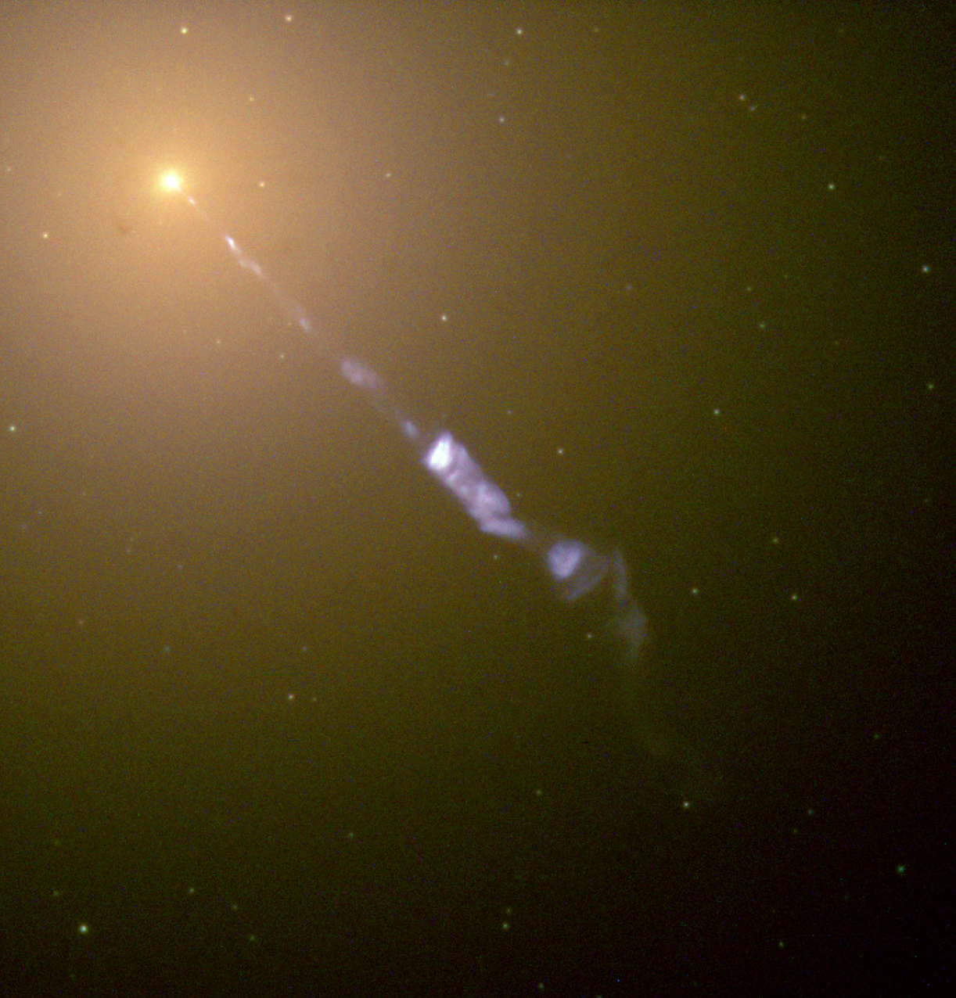

Astronomy Without A Telescope
Towards the end of 2009, the International Year of Astronomy, it was my privilege to be invited onto the writing team of Universe Today. After a few fumbling attempts at writing 'breaking news' stories, it came about that early on Sunday morning, 17 January 2010, I clicked Publish on an article entitled Astronomy Without A Telescope - Getting Orientated. And I relentlessly continued to do much the same thing for the next one hundred Sundays until Astronomy Without A Telescope - Special Relativity From First Principles was published on Sunday morning, 17 December 2011.
Astronomy Without A Telescope (AWAT or Eh? What?) was the subject of regular commentary from Universe Today's substantial readership - some expressing kind thoughts and others expressing outrage. But whatever kerfuffle ensued, it was all over in a few days - or at least until the next Sunday. This is the reality of 21st century internet publication. Clicking the Publish button is satisfying, but the real thrill comes when you check back to see what everyone said about what you wrote.
I dedicate this little book to my wife, who keeps reminding me to look up. I also tip my hat to the frequently opinionated, sometimes funny and occasionally brilliant commentators of Universe Today. Thanks.

Opposite photo: The touch of a supermassive black hole. First described as a 'curious straight ray' by astronomer H.D. Curtis in 1918, we now believe this to be the tail end of a 5,000 light year long jet of highly accelerated particles flung out from an accretion disk which surrounds a seven billion solar mass black hole embedded within the giant elliptical galaxy M87. Credit: NASA/Hubble Space Telescope.
Cover design by David Kammann
CONTENTS
1. Our Place In Space
You Are Here
The Only Way Is Up
The Hitchhikers Guide To The Solar System
Impact Mitigation
Our Unlikely Solar System
The Unlikeliness Of Being

2. Star Stuff
Alchemy By Supernova
Plausibility Check
Strange Stars
Stellar Quakes and Glitches
Jets
Galactic Gravity Lab

3. Einstein
Special Relativity From First Principles
Light Speed
Mass Is Energy
Can a Really, Really Fast Spacecraft Turn Into A Black Hole?
Gravity, Schmavity

4. The Universe
The Edge of Greatness
Flat Universe
One Crowded Nanosecond
Black Holes: The Early Years
Secular Evolution

5. Known Unknowns
Is Time Real?
Bubblology
Our Inferred Universe
Assumptions
Black Hole Entropy
What Can The Dark Matter Be?

6. Out Of Left Field
Is An Anomalous Anomaly A Normality?
Why The LHC (Still) Won’t Destroy The Earth
Granularity
The Universe Is Not In A Black Hole
Enough With The Dark Already
Warp Drive On Paper

7. Aliens
Planet Spotting
SETI 2.0
Alien Mining
Necropanspermia
Why Water?
Why Carbon?
1. Our place in space

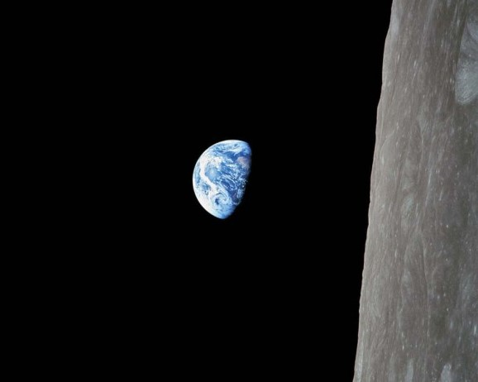
The iconic 'Earthrise' photo (AS08-14-2383) taken by Bill Anders on 24 December 1968 during the Apollo 8 mission. The image is often rotated to make the Moon's surface appear horizontal, but this is how it looked to Anders and crew as they flew around the edge of the Moon. Credit: NASA.

The stories in this first section are about the astronomical context in which we live. The reason why the same equatorial stars will rise about four minutes earlier each night is that, each night, we have shifted a little further in our orbit around the Sun. The Earth rotates once on its axis every 23 hours and 56 minutes, but we set our clocks to a twenty-four hour solar day because the Sun lingers in the sky just a bit longer due to our orbit around it.
As it happens we are orbiting the Sun at a fair clip - nearly 30 kilometers a second. One of our fastest spacecraft, New Horizons which is currently in transit towards a flyby of Pluto in 2015 only manages 16 kilometers a second. Although, to give the spacecraft due credit, it is on an outward radial trajectory - essentially flying 'uphill' out of the Sun's gravity well.
Taking another step out, our Sun, with its planets in tow, is steadily progressing around the galaxy at a jaw-dropping 220 kilometers a second. So while we talk of the importance of becoming a space-faring species - in reality, we already are and we always have been. But this awareness of our context has only come to us from going out to investigate the neighborhood - where we have begun to discover that we live in a dangerous place and, although you are not supposed to qualify the word unique, we have found that our planet does seem to be a bit unique.

You Are Here
February 18, 2010
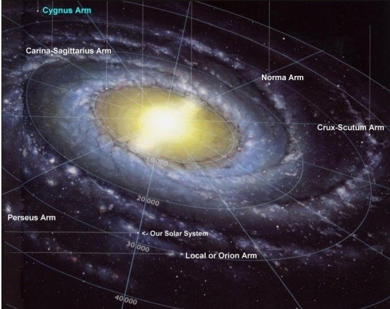
An artist's impression of the Milky Way galaxy, which we have never seen from the outside. Our solar system is over 27,000 light years from the center of the galaxy and probably less than 100 light years above its midplane. Credit: NASA.
You should always put out the old dinner set when you have astronomers around. It all starts innocently enough with imagine this wineglass is the Earth. But, then someone decides that a large plate is just right to show the orientation of an orbital plane and more wine glasses are brought to bear to test a solution to a three body problem and…
My favorite dinner set demonstration is to use the whole table to represent the galactic midplane – ideally with an upturned and wide-rimmed soup bowl sitting in the middle which mimics the galactic hub at the center of the Milky Way, visible in the constellation Sagittarius.
Then you get a dinner plate to represent the solar system’s orbital plane and hold it facing the galactic hub, at a 63-degree angle from the table top (because we know the equatorial plane of the Milky Way is tilted 63 degrees from the ecliptic). This means galactic north is straight up towards the ceiling – and for reference, following a line straight up along galactic north takes you to about where the star Arcturus would be in the real night sky.
Anyhow - now for the Earth. Wine glasses make an excellent Earth model since the stem can also represent the Earth’s axis of rotation. The glass is at least a bit round and you can see through it for a view of what someone would be able to see when standing on the Earth's surface.
Looking down on the solar system (plate) from its north, which is orientated away from the galactic hub (table), you should make the plate rotate anti-clockwise. If you hold the wine glass at the top of the plate – that’s Earth at about September, then you would move it to the left of the plate for December, down to the bottom for March, the right side of the plate for June and then back to the top for September again.
So, holding your plate at 63 degrees to the table, now hold the wine glass tilted at 23.5 degrees to the plate. In case you left your protractor at home –the wine glass stem should now be almost parallel to the table – since 63 + 23.5 is pretty close to 90 degrees. So now you can amaze your guests by showing how the Earth’s axis is almost perpendicular to the galactic axis.
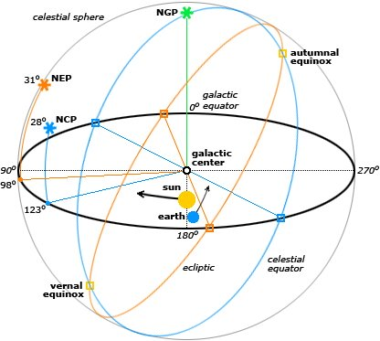
The range of different astronomical orientations available to you. Note that the axis of Earth's rotation (represented by the 'celestial equator') is almost perpendicular to the orbital plane of the galaxy. Credit: Wikimedia.
You should really imagine the plate being embedded within the table, since the Solar System lies well within the Milky Way's galactic disk. This is why you will always see some part of the Milky Way at night throughout the year. But, in any case, the wine glass gives a good demonstration of why we southern hemispheroids get such a splendid view of the galactic hub in Sagittarius. It’s hidden in the daytime around March – but come September at about 7pm you find the Milky Way running almost north-south across the sky with Sagittarius almost directly overhead. Arcturus is visible just above the western horizon, being about where the galaxy’s northern axis points.
And in September, if you look to the north you can see Vega just above the horizon – which is more or less the direction that the solar system (plate) is heading in its clockwise orbit around the galaxy (table).
Now, what is really interesting is if I add the Moon in by just, oh… er, sorry – that wasn’t new was it?

The Only Way Is Up
February 13, 2010
Alleged early astronaut Wàn Hù on the maiden flight of his rocket chair. Credit: Wikimedia.
Escaping a gravity well is never an easy proposition. Unlike other kinds of wells there are no walls, so your options are limited. Over the years we humans have experimented with a variety of ways of getting out – with varying levels of success.
Trying to build your way out was first attempted – at least allegorically – with the Tower of Babel which (again allegorically) did not go well. Even with today’s engineering, it remains a dubious prospect. The relatively new Burj Khalifa in Dubai has managed to scale only 830 meters. The official definition of where ‘space’ starts is 100 kilometers (or 60 miles).
Firing yourself out of a cannon or strapping explosives to your throne in the case of Wàn Hù, generally described as a minor official of the Ming Dynasty circa 1500, is similarly fraught with problems. See the MythBusters episode Ming Dynasty Astronaut to see how that worked out.
Even if you do survive the initial blast, the huge acceleration required to achieve a projectile escape velocity of 11.2 kilometers a second from sea level will kill you anyway. And then there’s the issue of atmospheric drag – at 11.2 kilometers a second the air in front of you will be compressed and superheated, so your already dead self will get cremated on the way up.
It would all be so much easier if someone could just throw down a rope. Various people have been attributed with first thinking up the space elevator, although it was probably Konstantin Tsiolkovsky. Building a space elevator involves launching a base station into geostationary orbit and then lowering down 36,000 kilometers of a carbon nanotube cable that we’ll be inventing any day now.
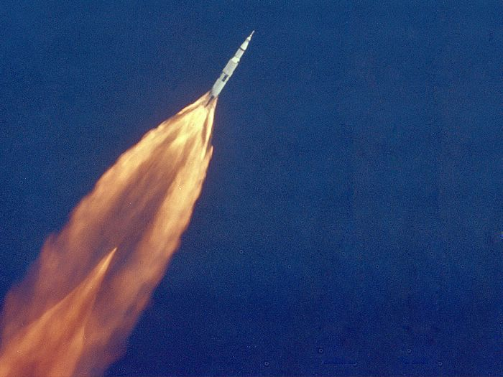
The Apollo 11 Saturn V in July 1969 - showing how it is really done. Credit: NASA.
For the moment at least, we are stuck with good old-fashioned rockets – for which we can also thank Mr Tsiolkovsky, amongst others. Although achieving an immediate 11.2-kilometers-a-second escape velocity from sea level will kill you – if you can get a bit of altitude at a non-lethal acceleration rate, you just need to steadily approach escape velocity. Indeed from higher altitudes the velocity needed to escape declines. So as long as you can launch with enough fuel to keep on gaining altitude, you be able to slowly and steadily escape the gravity well. We’ve done it with robotic spacecraft, even though we’ve never done it with people.
Remember that the Moon is still orbiting within Earth’s gravity well. Lagrange points 1 and 2, about 1.5 million kilometers away mark the edges of the Earth’s gravity well. Each is about four times the distance to the Moon, so that's a one-month round trip maybe. It’s still challenging and you’ll still collect radiation damage from cosmic rays – but nothing like the potentially suicidal two-year round trip to Mars. So, if we can get past this obsession with landing on things, wouldn’t it be a worthwhile goal to just try and finally get someone out of the well?

The Hitchhikers Guide To The Solar System
March 6, 2010
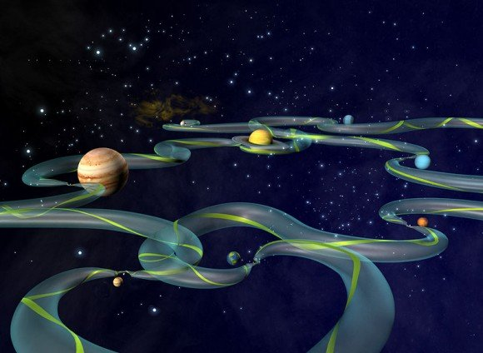Short on fuel, but good at astrophysics? It is possible to tour the solar system on less than 30 Altairian dollars a day by using the Interplanetary Transport Network (ITN). Credit: NASA.
The Interplanetary Transport Network (ITN) is based on gravity assist maneuvers and low energy transfer orbits around and between Lagrange points. Using the ITN, it is theoretically possible to tour the solar system with an exceedingly economic use of fuel as long as you have an abundance of patience and don’t mind taking an often circuitous route to your destination.
If you imagine the whole solar system as a rubber sheet which is warped by gravity wells, then the planets are really just small depressions of different depths pressed into the sides of the Sun’s overarching gravity well.
What’s important to this story is that the edges of those small depressions are nearly flat with respect to the otherwise steep slopes created by the Sun and the planets. It takes a lot less energy to move around on these flat edges than it does trying to climb straight up the steep slopes.
The flat edge that is present around the Earth’s gravity well is landmarked by Lagrange point 1 (or L1) lying directly between the Sun and the Earth – and Lagrange point 2 (L2) on the opposite side of the Earth directly away from the Sun. It is possible for a spacecraft to orbit a Lagrange point and thus be carried around the Sun with very little expenditure of energy. Because you are essentially riding the bow wave of the Earth as it orbits the Sun, you are carried along at the same orbital speed as the Earth (30 kilometers a second) without having to burn a lot of fuel in the process.
The Lagrange points also represent junction points that will enable low energy transfers between different planetary orbits. As though the solar system’s space-time curvature makes for a giant skateboard park, it’s possible to step off L1 and follow a trajectory down to Venus – or you can coast across the flat edge of Earth’s gravity well for about 3 million kilometers to L2 and then step off on a long winding path to the L1 of Mars. Here you might rest again before perhaps shuffling across to Mars’ L2 and then on to Jupiter.
Mathematical analysis of the gravitational interactions between multiple bodies (say, the Earth, the Sun and your spacecraft) is complex and has some similarities with chaos theory. But such an analysis can identify interconnecting pathways right across the solar system, which ITN proponents refer to as ‘tubes’.
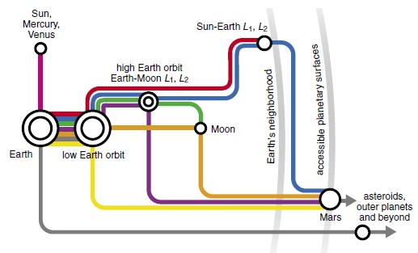
A 'tube map' of the interplanetary transport network Credit: NASA.
ITN principles have been adopted by a number of spacecraft missions to conserve fuel. Edward Belbruno proposed a low energy lunar transfer to get the Japanese probe Hiten into lunar orbit in 1991 despite it only having 10% of the fuel required for a traditional trans-lunar insertion trajectory. The maneuver was successful, although travel time to the Moon was five months instead of the traditional three days. NASA’s Genesis mission and the ESA’s SMART-1 are also considered to have used low energy ITN-like trajectories.
So impoverished hitchhikers, maybe you can still have that grand tour of planets by using the ITN – but make sure you pack a towel, it will be a very long trip.
Further reading: Ross, S.D. (2006) The interplanetary transport network.

Impact Mitigation
August 13, 2011
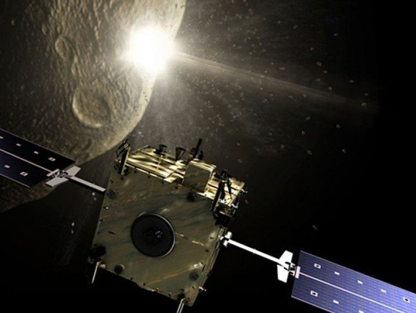
The Don Quijote mission, which may launch by 2015. The Sancho spacecraft will orbit an asteroid, collecting data as the Hidalgo spacecraft collides with that asteroid, in an attempt to alter its trajectory. Credit: ESA.
The save-the-Earth rehearsal mission Don Quijote, commissioned by the European Space Agency, is planned to test the potential of a real life-or-death mission to deflect a mass-extinction-inducing asteroid from a collision course with Earth.
Currently at ‘concept’ stage, the Don Quijote Near Earth Asteroid Impact Mitigation Mission has been modeled on a proposed flight to either 2002 AT4 or 1989 ML, both being near-Earth asteroids, though neither representing an obvious collision risk. However, it is already being discussed that 99942 Apophis may be an even better target. After all, 99942 Apophis does carry a marginal (1 in 250,000) risk of an Earth impact in 2036.
Whatever the target, a dual launch of two spacecraft is proposed – an Impactor called Hidalgo (a title Cervantes gave to the original Don Quijote) and an Orbiter called Sancho (who was the Don’s faithful companion).
While the Impactor’s role is self-explanatory, the Orbiter plays a key role in interpreting the impact – the idea being to collect impact momentum and trajectory change data that would then inform future missions, in which the fate of the Earth may really be at stake.
The extent of transfer of momentum from Impactor to asteroid depends on the Impactor’s mass (just over 500 kilograms) and its velocity (about 10 kilometers a second), as well as the composition and density of the asteroid. The greatest momentum change will be achieved if the impact throws up ejecta that achieve escape velocity. If instead the Impactor just buries itself within the asteroid, not much momentum change will be achieved, since the Impactor's mass will be substantially less than any mass-extinction-inducing asteroid. For example, the object that created the Chicxulub crater and wiped out the dinosaurs (yes, alright – except for the birds) is thought to have been of the order of 1 trillion metric tons.
So before the impact, to assist future targeting and impact velocity calculations, the Orbiter will make a detailed analysis of the target asteroid’s overall mass and its near-surface density and granularity. Then, after the impact, the Orbiter will assess the speed and distribution of the collision ejecta via its Impact Camera.
A precise determination of the Orbiter’s distance from the asteroid will be achieved by its Laser Altimeter, while a Radio Science Experiment will precisely determine the Orbiter’s position (and hence the asteroid’s position) relative to the Earth.
Having then established the Orbiter as a reference point, the effect of the Impactor's collision will be assessed. But, given the tiny velocity change we expect from the asteroid and given the importance of the Orbiter as a reference point, the tiny push contributed by solar radiation on both asteroid and spacecraft must also be taken into account. Furthermore, the Yarkovsky effect must be taken into account - which is the tiny amount of thrust caused by heated surfaces emitting their own radiation.
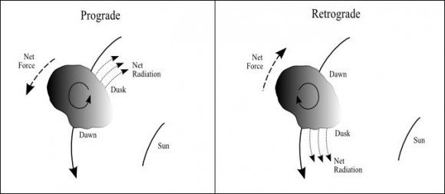
The heating of an asteroid's surface by the Sun causes it to radiate heat. How this changes the asteroid's trajectory depends on which way the asteroid is spinning because the strongest force is generated by surfaces that have just turned out of the Sun's light (i.e. 'dusk'). In asteroids with prograde spin, this will push the asteroid into a higher orbit - i.e. further away from the Sun. For asteroids with retrograde rotation, the orbit decays - i.e. towards the Sun. Credit: Wolters et al.
Indeed, we will also need to factor in that this effect will change as the shiny new spacecraft’s highly-reflective surfaces lose their sheen over the course of the mission. Highly reflective surfaces will emit radiation, almost immediately, at energy levels (i.e. high momentum) almost equivalent to the incident radiation. However, low albedo surfaces may only release lower energy (i.e. lower momentum) thermal radiation – and will do so more slowly.
To put it another way, a mirror surface makes a much better solar sail than a black surface.
So in a nutshell, the Don Quijote impact mitigation mission will require an Impactor with a Targeting Camera – and an Orbiter with an Impact Observation Camera, a Laser Altimeter, a Radio Science Experiment and a Thermal Infrared Spectrometer – and you should remember to measure the effect of solar radiation pressure on the spacecraft early in the mission, when it’s shiny – and later on, when it’s not.
Further reading: Wolters et al Measurement requirements for a near-Earth asteroid impact mitigation demonstration mission.

Our Unlikely Solar System
April 9, 2011
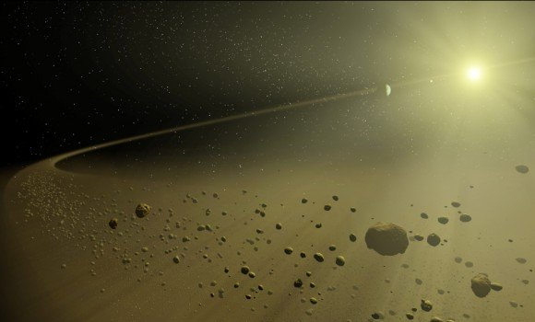
A circumstellar disk of debris around a matured stellar system may indicate that Earth-like planets lie within - since such a disk results from the collisional grinding of rocky planetesimals. Credit: NASA.
Recent modeling of Sun-like stars with planetary systems has found that a system with four rocky planets and four gas giants in stable orbits – and only a sparsely populated outer belt of planetesimals – has only a 15% to 25% likelihood of developing. While you might be skeptical about the validity of a model that puts our best-known planetary system in the unlikely basket, there may be some truth in this finding.
The modeling has been informed by the current database of known exoplanets and otherwise based on some reasonable assumptions about planet formation. Firstly, it is assumed that gas giants are unable to form within the frost line of a system – a line beyond which hydrogen compounds, like water, methane and ammonia would exist as ice. For our Solar System, this line is about 2.7 astronomical units from the Sun – which is roughly in the middle of the asteroid belt.
Gas giants can probably only form outside the frost line as their formation requires large amounts of solid material (in the form of ices) which eventually become the giant cores of these giant planets. While there may be just as much rocky material like iron, nickel and silicon outside the frost line, these materials are not abundant enough to play a significant role in forming giant planets and any planetesimals built from them are either gobbled up by the giants or flung out of orbit.
However, within the frost line, rocky materials are the dominant material for planet formation, since most light gases are blown out of the region by force of the stellar wind unless sustained by accretion within forming planetesimals of heavier materials (such as iron, nickel and silicates). Appreciably-sized rocky planets would probably form in these regions within 10-100 million years after the star’s birth.
So, perhaps a little parochially, it is assumed that you start with a system of three regions:
- an inner terrestrial planet forming region;
- a middle gas giant forming region; and
- an outer region of unbound planetesimals, where the star’s gravity is no longer sufficient to draw these objects into closer proximity.
Using this model as a base, Raymond et al ran a set of 152 variations, from which a number of broad rules emerged. Firstly, it seems that the likelihood of sustaining terrestrial inner planets is very dependent on the stability of the gas giants’ orbits. Frequently, gravitational perturbations amongst the gas giants results in them adopting more eccentric elliptical orbits which then clears out all the terrestrial planets – or sends them crashing into the star. Only 40% of systems retained more than one terrestrial planet, 20% had just one and 40% had lost them all.
Such a reconfiguration of our gas giants may have taken place in the early solar system - where an orbital resonance between Jupiter and Saturn (Saturn doing two orbits for every one of Jupiter's) created a gravitation pulse that kicked Neptune out past Uranus' orbit to the position it has now.
It's thought that this event may have prompted the Late Heavy Bombardment as Neptune ploughed into what was then a denser Kuiper belt sending Kuiper Belt objects flying both outwards and inwards. Those on an inward trajectory bombarded the inner planets - the scars of which we can still see on the Moon and on Mercury today - though persistent weathering, volcanism or plate tectonics have largely erased these scars from Mars, Venus and Earth.
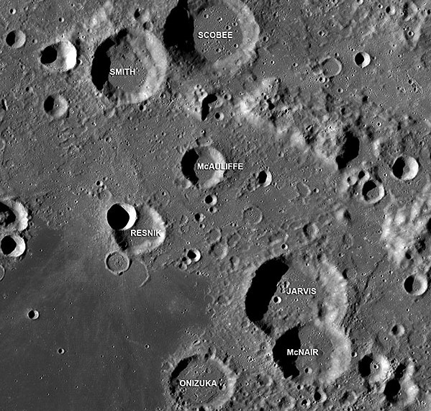
Signs of past heavy bombardment in the Apollo Basin on the Moon. The craters carry the names of the seven astronauts who died in the 1986 Space Shuttle Challenger disaster.
Anyhow, if this modeling work is correct, having more than one rocky planet puts us in a category shared by 40% of other stellar systems with planets - which is not all that unusual. What makes us an unlikely system is that we don't have a debris disk.
According to the modeling, debris disks of hot and cold dust should be common phenomena in matured systems which retain terrestrial planets. In all systems, primal dust is largely cleared out within the first few hundred million years – by radiation or by planets. But, where terrestrial planets are retained, there is a replenishment of this dust – presumably via collisional grinding of rocky planetesimals that were involved in building those terrestrial planets.
To explain this, it is proposed that the perturbations within our gas giants’ orbits, leading to the Late Heavy Bombardment, were indeed late with respect to how other systems usually evolve. This has left us with an unusually high number of terrestrial planets which had fully formed before the gas giant reconfiguration began. And the lateness of the event, after all the collisions which built the terrestrial planets were finished, cleared out most of the debris disk that might have been there. That is, apart from that faint hint of zodiacal light that you might notice in a dark sky after sunset or before dawn.
Further reading: Raymond et al Debris disks as signposts of terrestrial planet formation.

The Unlikeliness Of Being
July 30, 2011
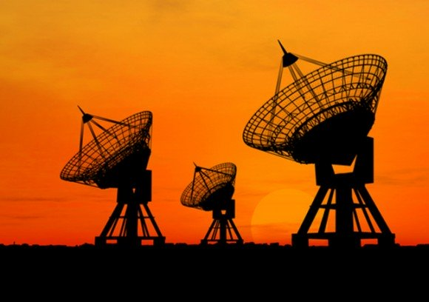
The search for extraterrestrial intelligence could be a complete waste of time according to a recent statistical analysis of the likelihood of life arising spontaneously on habitable-zone exoplanets (and when have predictive statistics ever got it wrong?). Credit: SETI Institute.
History has proven time and again that mathematical modeling is no substitute for a telescope (or other data collection device). Nonetheless, some theoreticians have recently put forward a statistical analysis which suggests that life is probably very rare in the universe – despite the apparent prevalence of habitable-zone exoplanets being found by the Kepler mission and other exoplanet search techniques.
You would be right to be skeptical, given the Bayesian analysis undertaken is based on our singular experience of abiogenesis – being the origin of life from non-life, here on Earth. Indeed, the seemingly rapid abiogenesis that occurred on Earth soon after its formation is suggested to be the clinching proof that abiogenesis on habitable-zone exoplanets must be rare. Hmm…
Bayes theorem provides a basis for estimating the likelihood that a prior assumption or hypothesis (e.g. that abiogenesis is common on habitable-zone exoplanets) is correct, using whatever evidence is available. Its usage is nicely demonstrated in solving the Monty Hall problem.

Go here for the detail, but in a nutshell:
There are three doors, one with a car behind it and the other two have goats. You announce which door you will pick – knowing that it carries a 1/3 probability of hiding the car. Then Monty Hall, who knows where the car is, opens another door to reveal a goat. So, now you know that door always had a zero probability of hiding the car. So, the likelihood of the remaining door hiding the car carries the remaining 2/3 probability of the system, since there was always an absolute 1/1 probability that the car was behind one of the three doors. So, it makes more sense for you to open that remaining door, instead of the first one you picked.
In this story, Monty Hall opening the door with a goat represents new data. It doesn’t allow you to definitively determine where the car is, but it does allow you to recalculate the likelihood that your prior hypothesis (that the car is behind the first door you picked) is correct.
Applying Bayesian analysis to the problem of abiogenesis on habitable-zone exoplanets is a bit of a stretch. Speigel and Turner argue that the evidence we have available to us – that life began quite soon after the Earth became habitable – contributes nothing to estimating the likelihood that life arises routinely on habitable-zone exoplanets.
They remind us that we need to acknowledge the anthropic nature of the observation we are making. We are here after 3.5 billion years of evolution – which has given us the capacity to gather together the evidence that life began here 3.5 billion years ago, shortly after the Earth first became habitable. But that is only because this is how things unfolded here on Earth. In the absence of more data, the apparent rapidity of abiogenesis here on Earth could just be a fluke.
Stromatolites - which were a fairly early form of life on Earth. Earth became inhabited by such early life shortly after it became habitable. This might seem suggestive that life is somewhat inevitable when the conditions are right. But a statistician is never going to buy such an argument when it is based on a single example.
This is a fair point, but a largely philosophical one. It informs the subsequent six pages of Spiegel and Turner’s Bayesian analysis, but it is not a conclusion of that analysis.
The authors seek to remind us that interviewing one person and finding that she or he likes baked beans does not allow us to conclude that all people like baked beans. Yes agree, but that’s just statistics – it’s not really Bayesian statistics.
If we are ever able to closely study an exoplanet that has been in a habitable state for 3.5 billion years and discover that either it has life, or that it does not – that will be equivalent to Monty Hall opening another door.
But for now, we might just be a fluke… or we might not be. What we need is more data.
Further reading: Spiegel and Turner. Life might be rare despite its early emergence on Earth: a Bayesian analysis of the probability of abiogenesis.

2. Star stuff

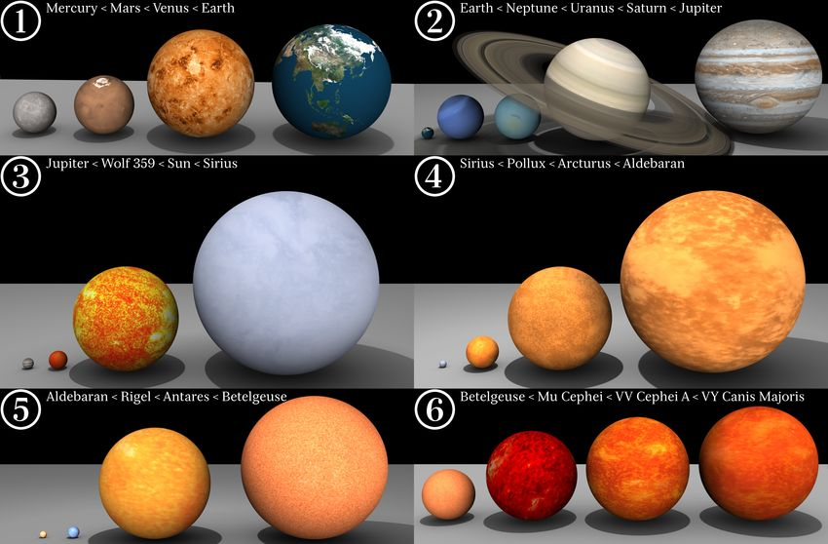A scale comparison chart showing just how big stars can get. However, everything after Rigel (frame 5) is kind of cheating because they are all red giants. When the Sun (frame 3) eventually goes red giant it will become about the size of Arcturus (frame 4). Credit: Wikimedia.

If you can accumulate matter together in sufficient amounts, an object will be produced that naturally adopts a spherical shape due to its own self-gravity. Keep adding more matter and the density of the object will continue increasing - and it will start heating up.
If you heat a solid you get a liquid, heat a liquid you get a gas, heat a gas and you get a plasma - the fourth state of matter. In a plasma, electrons become disassociated from nuclei and you get a mix of positively charged ions (the nuclei) and negatively charged electrons. So an initially neutral gas can become a plasma with electromagnetic properties. This means that it will start emitting electromagnetic radiation (i.e. light) and it can develop a substantial magnetic field, particularly if you spin it.
To get a gas of about three quarters hydrogen and one quarter helium to naturally form a sphere of hot, glowing magnetised plasma, you need one heck of a lot of gas - but that isn't a problem in our universe. According to recent estimates we have at least 3 x10²² stars (a three with 22 zeros after it) organised into at least 80 billion galaxies - and many people think that's an underestimate.
And of course, how stars get made is only half as interesting as what they do after that. Read on.

Alchemy By Supernova
August 14, 2010
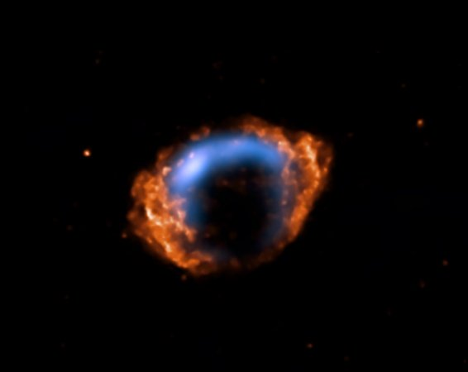
Supernova remnant G1.9+0.3. A combined image from Chandra X-ray data and radio data from NRAO's Very Large Array. Credit: Harvard/Chandra.
The production of elements in supernova explosions is something we take for granted these days. But exactly where and when such nucleosynthesis takes place is still unclear – and attempts to model core collapse scenarios still push current computing power to its limits.
Stellar fusion in main sequence stars can build some elements up to, and including, iron. Further production of heavier elements can also take place when certain seed elements capture neutrons to form isotopes. Those captured neutrons can then undergo beta decay leaving behind one or more protons - at which point you have a new element with a higher atomic number (since the atomic number of an element is just the number of protons in its nucleus).
This ‘slow’ process, or s-process, of building heavier elements like copper (29 protons), from a seed element like iron (26 protons), commonly takes place in red giants.
But there’s also the rapid or r-process, which takes place in a matter of seconds in core collapse supernovae (being supernovae types 1b, 1c and 2). Rather than the steady, step-wise building of new elements over thousands of years seen with the s-process – seed elements in a supernova explosion have multiple neutrons jammed into them, while also being exposed to disintegrating gamma rays. This combination of forces can build a wide range of both light and heavy elements, notably very heavy elements from lead (82 protons) up to plutonium (94 protons).
It’s thought that the r-process is probably over within a couple of seconds, but it could still take an hour or more before the supersonic explosion front bursts through the surface of the star, delivering some fresh contributions to the periodic table.
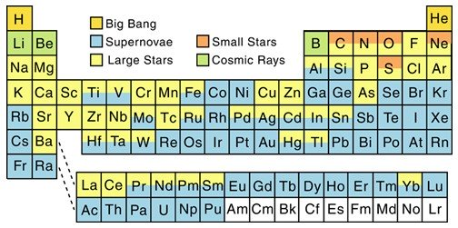
How stuff gets made in our universe. The preponderance of blue indicates just how much of the periodic table owes its existence to supernovae. The white elements (above plutonium) can be formed in a laboratory, but it is unclear whether they form naturally - and, in any case, they decay quickly after they are formed. Credit: North Arizona University.
There's a little known process called cosmic ray spallation that gives us most of the lithium, beryllium and boron in the universe - although these are a tiny proportion of the universe's contents.
As it happens, most of the elements in the universe are hydrogen (73%) and helium (25%). The hydrogen formed in the first three minutes of the universe. The helium formed within the next 17 minutes - as the entire universe, still as hot as the core of the Sun facilitated the fusion of hydrogen to helium. After the first 20 minutes, the universe had expanded and cooled too much for any further nucleosynthesis to take place - and it was then up to gravity to accumulate mass into stars.
Smallish stars can drive fusion that is sufficient to produce carbon, nitrogen, oxygen and even neon and silicon - while bigger stars can generate more complex fusion reactions including s-process nucleosynthesis.
The really big stars that form supernovae create much of the huge diversity of elements we see in the periodic table, including the gold of many a wedding ring - though proportionally you could hardly say that supernovae are what make up most of the elements that are essential to us carbon-based life forms. We are 96% carbon, nitrogen and oxygen - a bit of hydrogen and a bunch of non-supernovae dependent trace elements.
So, yes, we are star stuff, but not especially supernovae stuff. At best we might thank the supernovae for spreading the stuff around. For example, much of the iron we need for hemoglobin might still be stuck inside dead stellar cores were it not for the propensity of big stars to blow themselves to bits.
Further reading: Arcones A. and Janka H. Nucleosynthesis-relevant conditions in neutrino-driven supernova outflows. II. The reverse shock in two-dimensional simulations.
And, for historical context, the seminal paper on the subject is: E. M. Burbidge, G. R. Burbidge, W. A. Fowler, and F. Hoyle. (1957). Synthesis of the Elements in Stars. (Before this nearly everyone thought all the elements formed in the Big Bang – everyone except Fred Hoyle anyway).

Plausibility Check
February 12, 2011
Two binary stars shining through an atmosphere containing semi-precipitous water vapor (also known as clouds). Is this really plausible? Credit: NASA.
So we all know this story. Uncle Owen has just emotionally blackmailed you into putting off your application to the academy for another year – and even after you just got those two new droids, darn it. So you stare mournfully at the setting binary suns and…
Hang on, they look a lot like spectral class G stars – and if so, their roughly 0.5 degree angular diameters in the sky suggest they are both only around 1 astronomical unit away. I mean OK, you could plausibly have a close red dwarf and a distant blue giant having identical apparent diameters, but surely they would look substantially different, both in color and brightness.
So if those two suns are about the same size and at about the same distance away, then you must be standing on a circumbinary planet that encompasses both stars in one orbit.
To allow a stable circumbinary orbit – either a planet has to be very distant from the binary stars – so that they essentially act as a single center of mass – or the two stars have to be really close together – so that they essentially act as a single center of mass. It’s unlikely a planet could maintain a stable orbit around a binary system where it is exposed to pulses of gravitational force, as first one star passes close by, then the other passes close by.
Anyhow, if you can stand on a planet and watch a binary sunset – and you are a water-solvent based life form – then your planet must be within that star system’s habitable zone where H₂O can exist in a fluid state. Given this – and the stars apparent size and proximity to each other, it’s most likely that you orbit two stars that are really close together.
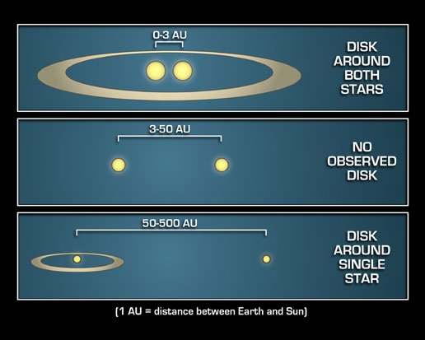
To get a planet in a habitable zone around a binary system - your choices are probably limited to circumbinary planets around two close binaries - or circumstellar planets around one star in a widely spread binary. Credit: NASA/JPL.
But, taking this further – if we accept that there are two G type stars in the sky, then it’s unlikely that your planet is exactly one astronomical unit from them – since the presence of two equivalent stars in the sky should roughly double the stellar flux you would get from one. And it’s not a simple matter of doubling the distance to halve the stellar flux. Doubling the distance will halve the apparent diameters of the stars in the sky, but an inverse square relation applies to their brightness and their solar flux, so at double the distance you would only get a quarter of their stellar flux. So, something like the square root of two, that is about 1.4 astronomical units away from the stars, might be about right.
However, this means the stars now need a larger than solar diameter to create the same apparent size that they have in the sky – which means they must have more mass – which will put them into a more intense spectral class. For example, Sirius A has 1.7 times the diameter of the Sun, but about 25 times its absolute luminosity. So even at 2 astronomical units distance, Sirius A would be nearly five times as bright and deliver five times as much stellar flux as the Sun does to Earth – or ten times if there are two such stars in the sky.
So, to summarize…
If you are in a circumbinary orbit around two equivalent stars, it is conceivable that you could see those two stars in your sky – possessing the same apparent diameter and brightness. However, it’s a struggle to come up with a plausible scenario whereby those stars could have the angular diameter in the sky that they appear to have in the movie and still have your planet within the system’s habitable zone.
OK, you live on a desert world, but two stars of a more intense spectral class than G would probably blow away the atmosphere. And even two G type stars would give you a lead-melting Venus scenario, which receives roughly double the solar flux that Earth does, because it's 28% closer to the Sun.
Alternatively the two stars in your sky could be smaller K or M class stars, but then they should be much redder than they appear to be. And being less massive stars, your planet would orbit much closer in – towards that range where it’s unlikely that your planet could retain a stable orbit around both stars.
Or to summarize the summary, it’s just a movie.

Strange Stars
August 7, 2010
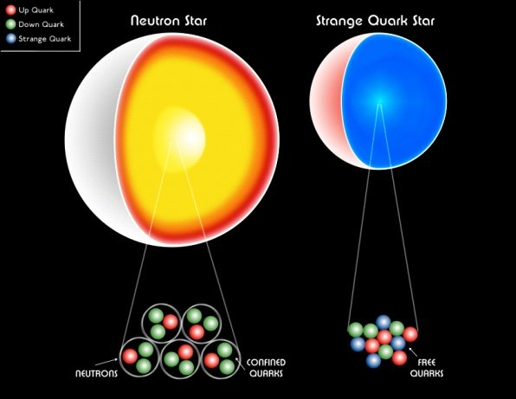
A hypothetical strange star results from extreme gravitational compression overcoming the strong interaction that sustains the structure of neutrons within a neutron star. Credit: Swinburne University.
Atoms are made of protons, neutrons and electrons. If you cram them together and hence heat them up you get plasma, where electrons are split off atomic nuclei. So, you get a hot and light-emitting mixture of positively charged ions and negatively charged electrons. If you cram that matter together even further, you drive electrons to merge with protons and you are just left with a collection of neutrons – like in a neutron star. So, what if you keep cramming that collection of neutrons together into an even higher density? Well, eventually you get a black hole – but before that (at least hypothetically) you get a strange star.
Theory has it that further compressing these neutrons will eventually overcome the strong nuclear force – meaning the neutrons will break down into their constituent quarks. This results in a roughly equal mix of up, down and strange quarks which can be crammed even closer together within a smaller volume. By convention, this compressed collection of quarks is called strange matter.
Anyhow, if they exist at all, strange stars should have some telltale characteristics. We know that neutron stars tend to be in the range of 1.4 to 2 solar masses – and that any star with a neutron star’s density that’s over 10 solar masses has to become a black hole. So the gap for strange stars to form may be somewhere in that 2 to 10 solar masses range.
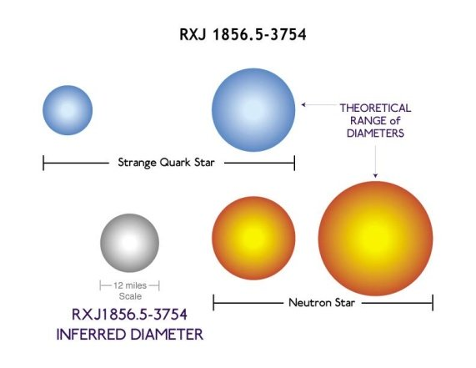
By adopting a more compressed 'ground state' of matter, a strange (quark) star should be smaller, but more massive, than a neutron star. RXJ1856 is in the ballpark for size, but may not be massive enough to fit the theory. Credit: Harvard/Chandra.
Another predicted characteristic of a strange star should be a size that is smaller than most neutron stars. One strange star candidate is RXJ1856, which appears to be a neutron star, but is only 11 kilometers in diameter. Astrophysicists have been heard to mutter Huh… that’s strange on hearing about it – but its strangeness remains to be confirmed.
Further reading: Negreiros et al (2010) Properties of Bare Strange Stars Associated with Surface Electrical Fields.

Stellar Quakes and Glitches
May 22, 2010
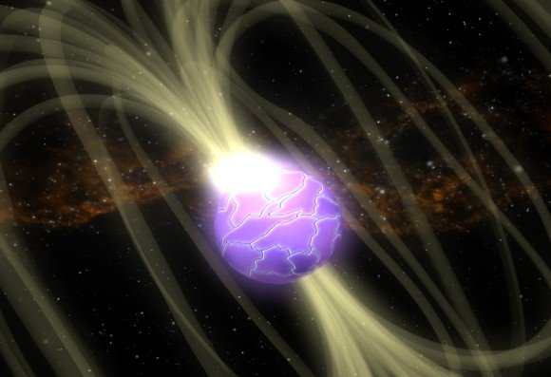The upper crust of a neutron star is thought to be composed of crystallized iron, may have centimeter high mountains and experiences occasional ‘star quakes’ which may precede what is technically known as a glitch. These glitches and the subsequent post-glitch recovery period may offer some insight into the nature and behavior of the superfluid core of neutron stars. Credit: NASA.
The events leading up to a neutron star quake go something like this. Firstly, all neutron stars tend to ‘spin down’ during their life cycle, as their magnetic field applies the brakes to the star’s spin.
During this dynamic process, two conflicting forces operate on the geometry of the star. Its very rapid spin tends to push out the star’s equator, making it an oblate spheroid. But, at the same time, the very strong gravity of the star is also working to make the star conform to the shape of a perfect sphere (i.e. a state of hydrostatic equilibrium).
Thus, as the star spins down, its crust – which is reportedly 10 billion times the strength of steel – tends to buckle under the strain. There may be a process, like the shifting of tectonic plates – which create ‘mountains’ only centimeters high, but which extend for several kilometers over the star’s surface. This tectonic shifting may relieve some of stresses the crust is experiencing – but, as the process continues, the tension builds up and up until something has to give.
The sudden collapse of a 10 centimeter high mountain on the surface of a neutron star is a dramatic event and may be associated with a major readjustment in the neutron star's magnetic field.
It may be that the tectonic shifting of crustal segments works to ‘wind up’ the magnetic lines of force sticking out past the neutron star’s surface. Then, in a star quake event, there is a sudden and powerful energy release - which may be a result of the star’s magnetic field dropping to a lower energy level as the star’s geometry changes. This energy release involves a huge flash of X-rays and gamma rays.
In the case of a magnetar-type neutron star, this flash can outshine most other x-ray sources in the universe. Magnetar flashes also pump out substantial gamma rays – although these are referred to as soft gamma ray (SGR) emissions to distinguish them from more energetic gamma ray bursts (GRB) resulting from a range of other phenomena in the universe.
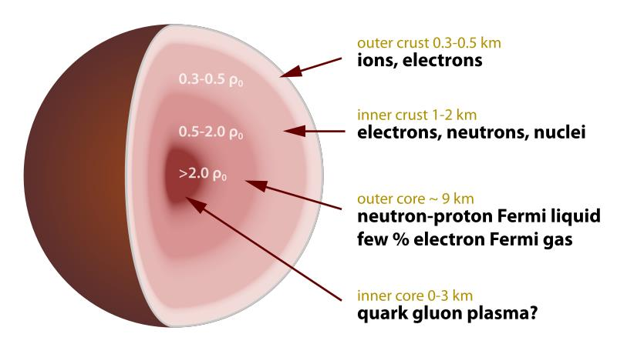
Cross section of a neutron star. Although it is predominantly neutrons, a perfect state of closely packed neutrons is only achieved at about a nuclear saturation density of ρ0 = 1.0. The less dense outer crust (ρ0 < 1.0) may still be composed of conventional matter. Towards the inner core (ρ0 > 1.0) neutrons are further compressed and stretched (the term nuclear pasta is sometimes used) and the inner core is usually labeled with a question mark - some kind of quark matter perhaps. Credit: Wikimedia.
Along with the quake and the radiation burst, neutron stars may also experience a glitch – which is a sudden and temporary increase in the neutron star’s spin. This is likely to be the result of conservation of angular momentum as the star’s equator sucks itself in a bit.
The same conservation of angular momentum effect can also be seen when skaters pull their arms in as they are spinning - which (temporarily) makes them spin even faster. Another example of how pretty much everything that goes on in the world has something to do with astronomy.

Jets
October 23, 2010
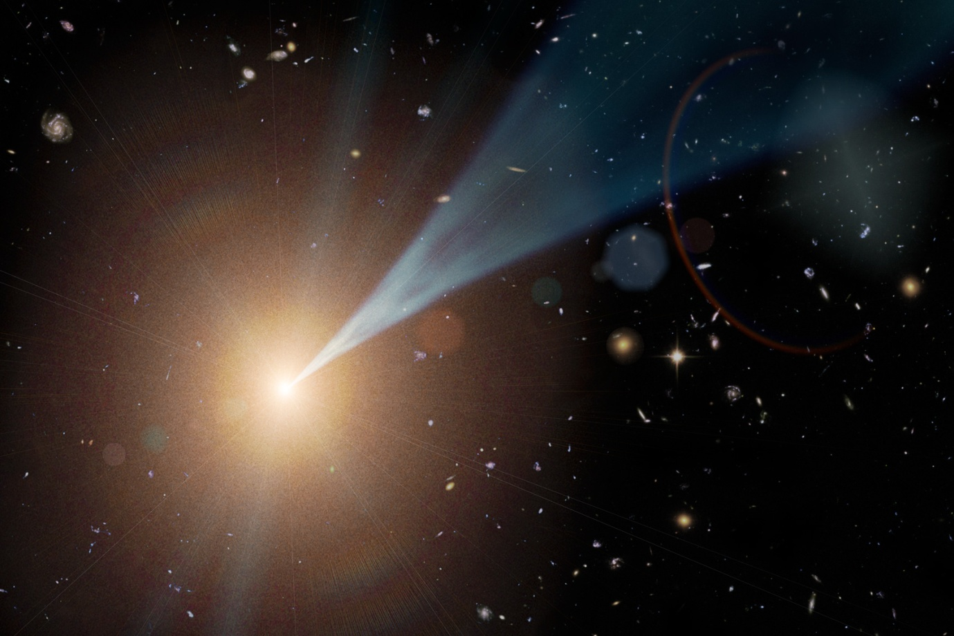
Black holes trap light within their event horizons and hence should be invisible. But if they are actively consuming new mass, then all the matter that is being dragged towards them is spun around like water falling into a plug hole. These spinning accretion disks generate huge jets that can broadcast the presence of the black hole across the universe. Credit: NASA.
Polar jets are often found emerging from objects with spinning accretion disks – anything from newly forming stars to ageing neutron stars. And some of the most powerful polar jets arise from accretion disks around black holes, be they of stellar or supermassive size. In the latter case, jets emerging from active galaxies such as quasars, with their jets roughly orientated towards Earth, are called blazars.
The physics underlying the production of polar jets at any scale is not completely understood. It is likely that twisting magnetic lines of force, generated within a spinning accretion disk, channel plasma from the compressed centre of the accretion disk into the narrow jets that we observe.
In the extreme cases of black hole accretion disks, jet material acquires escape velocities close to the speed of light – which is needed if the material is to escape from the vicinity of a black hole.
Such relativistic jets from blazars broadcast energetically across the electromagnetic spectrum – where ground based radio telescopes can pick up their low frequency radiation, while space-based telescopes, like Fermi or Chandra, can pick up high frequency radiation. As you can see from the lead image of this story, Hubble can pick up optical light from one of M87‘s jets – although ground-based optical observations of a ‘curious straight ray’ from M87 were recorded as early as 1918.
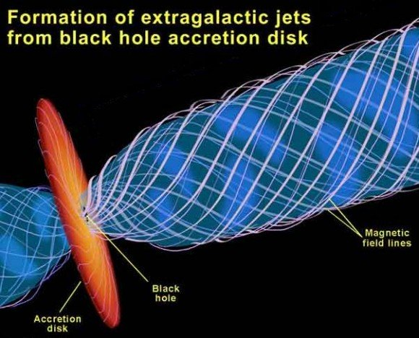
Polar jets are thought to be shaped (collimated) by twisting magnetic lines of force. The driving force that pushes the jets out may be magnetic or just the result of very intense radiation pressure - no-one is really sure yet. Credit: NASA.

Such jets could represent a form of 'Death from the Skies' (the title of a good book by Dr Phil Plait) - if we were close to the source and the jet was directly orientated at Earth. The impact of such a concentrated beam of high-energy sub-atomic particles would be sufficient to overcome the protection offered by the Earth's magnetic field and it would then proceed to blow the atmosphere away and lethally irradiate us at the same time.

Fortunately, it's not hard to spot an active galaxy with blazar jets - and there are none nearby with jets pointed right at us - nor are there any new kids on the block that are likely to light up anytime soon.

Galactic Gravity Lab
August 28, 2010
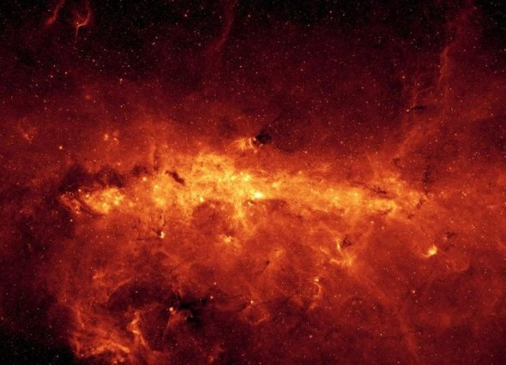
The center of the Milky Way containing Sagittarius A*. The supermassive black hole and several massive young stars in the region create a surrounding haze of superheated gas that shows up in X-ray light. Credit: Harvard/Chandra and Kyoto University.
Many an alternative theory of gravity has been dreamt up in the bath, while waiting for a bus – or maybe over a light beverage or two. These days it’s becoming possible to test your own pet theory by predicting on paper what should happen to an object that is closely orbiting a black hole – and then test those predictions. This testing is made possible through making observations of stars like S2 that are closely orbiting our galaxy’s central supermassive black hole – situated at the radio source Sagittarius A*.
S2, a bright B spectral class star, has been closely observed since 1995 during which time it has completed just over one orbit of the black hole (that is, its orbital period is less than 16 years). S2’s orbital dynamics can be expected to differ from what would be predicted by Kepler’s 3rd law and Newton’s law of gravity. The same anomalous effect is just detectable in the orbit of Mercury. In both Mercury’s and S2’s cases, these apparently anomalous effects are predicted by Einstein’s theory of general relativity, as a result of the curvature of space-time caused by a nearby massive object – the Sun in Mercury’s case and the black hole in S2’s case. But the anomalous effect seen in S2's orbit is three orders of magnitude greater than that seen in Mercury's.
At the periapsis (closest-in point) of its orbit, S2 is thought to come within 5 billion kilometers of the event horizon of the supermassive black hole, being the boundary beyond which light can no longer escape. The supermassive black hole’s event horizon has roughly the diameter of the orbit of Mercury – and at periapsis, S2 is roughly the same distance away from the event horizon as Pluto is from the Sun.
The supermassive black hole is estimated to have a mass of roughly four million solar masses, meaning it may have dined upon several million stars since its formation in the early universe – and meaning that S2 only barely manages to cling on to existence by virtue of its stupendous orbital speed of about 5,000 kilometers per second – which is nearly 2% of the speed of light. This keeps it falling around, rather than falling into, the black hole. For comparison, Pluto stays in orbit around the Sun by maintaining a leisurely orbital speed of about 5 kilometers per second.
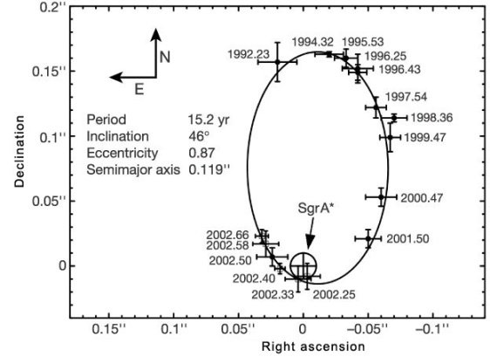
A detailed data set of S2’s astrometric position (right ascension and declination) during its orbit around the supermassive black hole Sagittarius A*. These data points indicate that S2 must be orbiting a mass of over 4 million solar masses and that the diameter of that mass is so compact that it just has to be a black hole. Credit: Schödel et al/Nature.

3. Einstein

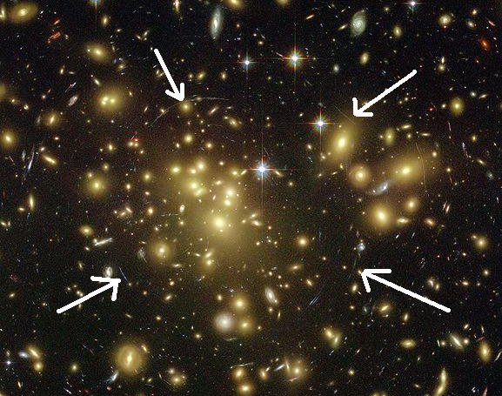
Gravitational lensing in action - faint hints of an 'Einstein ring' forming about light sources which have been 'lensed' by the gravitational warping of space-time. If the galactic cluster causing the warping was orientated in a plane that was face-on directly at Earth - the Einstein ring would be much more apparent. Credit: NASA/Hubble Space Telescope.

Everyone should at least try to understand how Einstein saw the universe. It is an absorbing intellectual exercise that might help pass the time when you become trapped in an elevator for several hours - say after a massive solar flare wipes out the power grid.
Einstein’s genius is not so much exemplified by the horribly complex math that underlies his relativity theories – but in the way that the theories require us to reconsider some the most fundamental aspects of our daily experience. With an understanding of relativity, going to the shops to buy some milk can become a remarkable exercise in motion through space and time and a ride up an elevator is even more extraordinary.
Our common experiences of motion and of ageing represent our ordinary engagement with our extraordinary space-time universe. And who would have thought the same logic that explains motion also ends up explaining gravity?
Although Einstein's relativity really is full of horribly complex math - there are heuristic explanations (that is, plain English approximations) that will enable you to get the general idea of relativity and the idea of general relativity.
With just this heuristic understanding of Einstein's relativity you should come to appreciate that:
- Light speed is not the limit that many people assume. Relativity theory permits you to cross a light year in considerably less than a year, even though you never get to move faster than light.
- There’s nothing especially remarkable about how light moves, it just moves as fast as it is possible for anything to move. Our universe's ultimate speed is determined by the unification of space and time.
- You can annoy quantum physicists by showing how gravity is just a consequence of space-time geometry. The phrase "force of gravity" should be met with a snort of derision.
When all that makes sense, you are ready to embrace the 21st century. Hopefully the following stories will help you on your way.

Special Relativity From First Principles
December 17, 2011
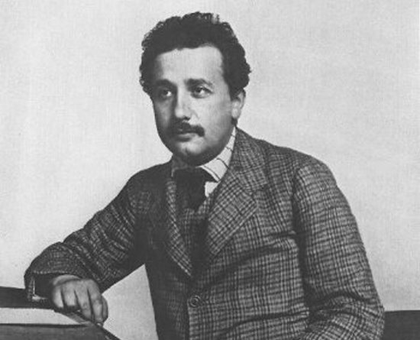
There's hope for us all if a mild-mannered patent office clerk can become Person Of The 20th Century. Credit: Wikimedia.
Einstein’s explanation of special relativity, delivered in his 1905 paper On the Electrodynamics of Moving Bodies focuses on demolishing the idea of ‘absolute rest’, exemplified by the theoretical luminiferous aether. He achieved this very successfully, but many hearing that argument today are left puzzled as to why everything seems to depend upon the speed of light in a vacuum.
Since few people in the 21st century need convincing that the luminiferous aether does not exist, it is possible to come at the concept of special relativity in a different way and just through an exercise of logic deduce that the universe must have an absolute speed – and from there deduce special relativity as a logical consequence.
The argument goes like this:
1) There must be an absolute speed in any universe since speed is a measure of distance moved over time. Increasing your speed means you reduce your travel time between a distance A to B. At least theoretically, you should be able to increase your speed up to the point where that travel time declines to zero – and whatever speed you are at when that happens will represent the universe’s absolute speed.
2) Now consider the principle of relativity. Einstein talked about trains and platforms to describe different inertial frames of reference. So for example, you can measure someone throwing a ball forward at 10 km/hr on the platform. But put that someone on the train which is travelling at 60 km/hr and then the ball measurably moves forward at nearly 70 km/hr (relative to the platform).
3) Point 2 is a big problem for a universe that has an absolute speed (see Point 1). For example, if you had an instrument that projected something forward at the absolute speed of the universe and then put that instrument on the train – you would expect to be able to measure something moving at the absolute speed + 60 km/hr.
4) Einstein deduced that when you observe something moving at the absolute speed in a different frame of reference to your own, the components of speed (i.e. distance and time) must change in that other frame of reference to ensure that anything moving at the absolute speed can never be measured moving at a speed greater than the absolute speed.
Thus on the train, distances should contract and time should dilate (since time is the denominator of distance over time).
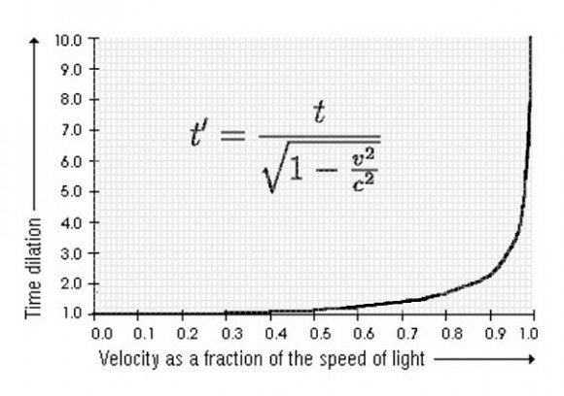
The effect of relative motion. Measurable time dilation is negligible on a train moving past a platform at 60 km/hr, but increases dramatically if that train acquires the capacity to approach the speed of light. Time (and distance) will change to ensure that light speed is always light speed, not light speed + the speed of the train.
And that’s it really. From there one can just look to the universe for examples of something that always moves at the same speed regardless of frame of reference. When you find that something, you will know that it must be moving at the absolute speed.
Einstein offers two examples in the opening paragraphs of On the Electrodynamics of Moving Bodies:
- the electromagnetic output produced by the relative motion of a magnet and an induction coil is the same whether the magnet is moved or whether the coil is moved (a finding of James Clerk Maxwell‘s electromagnetic theory) and;
- the failure to demonstrate that the motion of the Earth adds any additional speed to a light beam moving ahead of the Earth’s orbital trajectory (presumably an oblique reference to the 1887 Michelson-Morley experiment).
In other words, electromagnetic radiation (i.e. light) demonstrated the very property that would be expected of something which moved at the absolute speed that it is possible to move in our universe.

The fact that light happens to move at the absolute speed of the universe is useful to know – since we can measure the speed of light and hence we can then assign a numerical value to the universe’s absolute speed (i.e. 300,000 kilometers a second), rather than just calling it c.

Light Speed
October 8, 2011
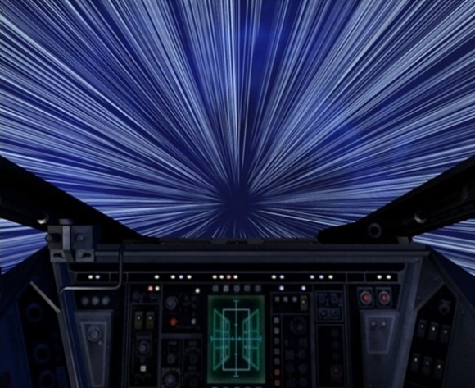
You could cross the galaxy in a matter of minutes without ever 'breaking light speed' - it is not the speed limit that it seems to be. Credit: Anon, sourced from http://phys.org.
The recent allegation that neutrinos can move faster than light might have got everyone thinking about warp drive and all that, but really relativity physics already allows you to star trek across the universe without ever needing to move faster than light.
Light speed, or 300,000 kilometers a second, might seem like a speed limit, but this is just an example of 3 + 1 thinking – where we still haven’t got our heads around the concept of four dimensional space-time and hence we think in terms of space having three dimensions and think of time as something separate and immutable.
For example, from our perspective it takes a light beam 4.3 years to go from Earth to the Alpha Centauri system. But if you were to hop on a spacecraft going at 99.999 per cent of the speed of light you would get to Alpha Centauri in a matter of days, hours or even minutes – depending on just how many .99s you add on to the per cent of light speed that you move at.
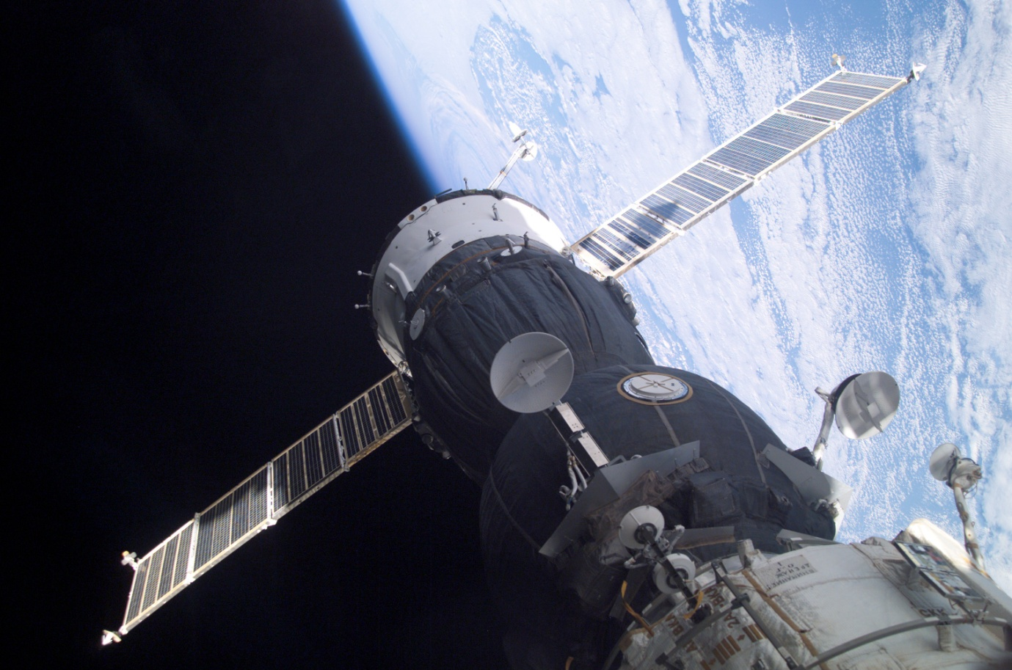
A Soyuz spacecraft docking with the International Space Station (ISS). It is estimated that you would gain an extra second for every 80 years you spent in low Earth orbit as a consequence of your velocity relative to someone on the surface. Credit: Wikimedia.
We are stuck on the idea that light speed is a speed limit, because we intuitively believe that time runs at a constant rate. But we already have a significant body of evidence to indicate that time actually passes at different rates when compared between different frames of reference that are moving at relatively different speeds.
So star trekking really does start looking feasible if you are able to move at nearly the speed of light. This is because when you travel near light speed, as you twist the throttle you really do achieve a further reduction in your trip duration - but this is because of the time dilation effect rather than an increase in your speed.
And it's not just about time dilation. As you approach light speed, the universe measurably contracts in the direction of your travel. For example, as you speed towards Alpha Centauri, the distance that you had measured as 4.3 light years from Earth becomes less when you measure it from your spacecraft. This is why you will never measure yourself as breaking light speed even though you really can travel from Earth to Alpha Centauri in less than 4.3 years.
So, even though star drives can't increase your speed beyond light speed, they can still substantially reduce your travel time between two distant points.
We struggle to grasp this because people intuitively believe that space is somehow separate from time. But really both are part of the same thing, space-time. You can't cross any distance in space without also moving through time. So at near light speed you can cross the galaxy while you make a quick cup of tea, even though eons will pass by back on Earth - since on Earth we measure the diameter of the galaxy as being over 100,000 light years.
If you really could move at light speed - like a photon - you would have no perception of distance or time. If you were able to move at the fastest speed possible, the universe would be completely contracted in your direction of motion and no time would pass before you reached a distant point - whether that distance point was the other side of the room or the other side of the galaxy.
As Woody Allen once said: Time is nature’s way of keeping everything from happening at once. Space-time is nature’s way of keeping everything from happening in the same location at once.

Mass Is Energy
November 19, 2011
The USS Enterprise in 1964 (pre Zefram Cochrane era), during Operation Sea Orbit when it sailed around the world in 65 days without refueling - demonstrating the capability of nuclear-powered ships. Credit: US Navy.
Some say that the reason you can’t travel faster than light is that your mass will increase as your speed approaches light speed – so, regardless of how much energy your star drive can generate, you reach a point where no amount of energy can further accelerate your spacecraft because its mass is approaching infinite.
This line of thinking is at best an incomplete description of what’s really going on and is not a particularly effective way of explaining why you can’t move faster than light (even though you really can’t). However, the story does offer useful insight into why mass is equivalent to energy, in accordance with the relationship e=mc².
Firstly, here’s why the story isn’t complete. Although someone back on Earth might see your spacecraft’s mass increase as you move near light speed – you the pilot aren’t going to notice your mass change at all. Within your spacecraft, you would still be able to climb stairs, jump rope – and if you had a set of bathroom scales along for the ride you would still weigh just the same as you did back on Earth (assuming your ship is equipped with the latest in artificial gravity technology that mimics conditions back on Earth’s surface).
The change perceived by an Earth observer is just relativistic mass. If you hit the brakes and returned to a more conventional velocity, all the relativistic mass would go away and an Earth observer would just see you retaining the same proper (or rest) mass that the spacecraft and you had before you left Earth.
The Earth observer would be more correct to consider your situation in terms of momentum energy, which is a product of your mass and your velocity. So, as you pump more energy into your star drive system, your momentum increases. But an observer back on Earth would correctly interpret this as a mass increase, since your velocity doesn’t increase much at all once it is up around 99% of the speed of light. Then when you slow down again, you appear to lose mass as you offload energy – perhaps by converting your kinetic energy of motion into heat (assuming your spacecraft is equipped with the latest in relativistic braking technology).
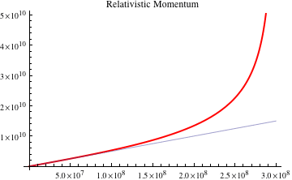
As your spacecraft velocity approaches light speed (3 x 10⁸ meters a second), your relativistic momentum measured from Earth (red line) departs from the momentum expected by classical physics (blue line), and your measured momentum begins approaching infinite. Credit: Anon, sourced from www.batesville.k12.in.us.
From the perspective of the Earth-based observer, you can formulate that the relativistic mass gain observed when travelling near light speed is the sum of the spacecraft’s rest mass/energy plus the kinetic energy of its motion – all divided by c². From that you can (stepping around some moderately complex math) derive that e=mc². This is a useful finding, but it has little to do with why the spacecraft’s speed cannot exceed light speed.
When you the pilot approach light speed and still keep pumping more energy into your drive system, what you find is that you keep reaching your destination faster. This is not so much because you are moving faster, but because the time you estimated it would take you to cross the distance from point A to point B becomes measurably less, indeed the distance between point A to point B also becomes measurably less. So you never break light speed because the distance over time parameters of your journey keep changing in a manner that ensures that you never break light speed.
But, anyway... measuring the relativistic mass that a near-light-speed spacecraft gains is the best way to derive the relationship e=mc², since that relativistic mass is a direct result of the kinetic energy of the spacecraft's motion.
The mass-energy relationship is not so easy to calculate from a nuclear explosion. Much of the energy of the blast derives from the release of the binding energy which holds a heavy atom's sub-atomic particles together, rather than from the direct conversion of matter to energy. A nuclear blast is more about energy transformation, although at a system level it still represents genuine mass to energy conversion, since binding energy does contribute mass to a system.
To keep it simple, did you know that your cup of coffee is more massive when it’s hot – and gets measurably less massive when it cools down? Matter, in terms of protons, neutrons and electrons, is largely conserved throughout this process. But, for a little while, the heat energy really does add to the mass of the coffee cup system – although since it is a mass of m=e/c², we are talking about a very tiny amount of mass.

Can a Really, Really Fast Spacecraft Turn Into A Black Hole?
February 15, 2010
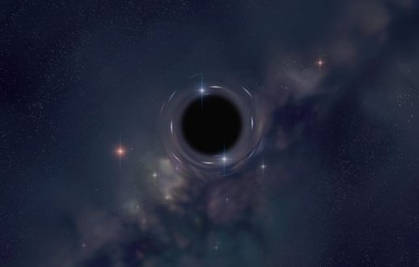
Black holes - they're big and they're black, which doesn't make them immediately photogenic. But they do warp the space-time around them, which can produce some interesting boundary effects. Credit: NASA.
Imagine a scenario where a spacecraft gains relativistic mass as it approaches the speed of light, while at the same time its volume is reduced via relativistic length contraction. If these changes can continue towards infinite values (which they can) – it seems you have the perfect recipe for a black hole.
Of course, the key word here is relativistic. Back on Earth, it can appear that a spacecraft which is approaching the speed of light is indeed both gaining mass and shrinking in volume. Also, light from the spacecraft will become increasingly redshifted – potentially into almost-blackness. This can be partly Doppler effect for a receding spacecraft, but is also partly a time dilation effect where the sub-atomic particles of the spacecraft seem to oscillate slower and hence emit light at lower frequencies.
So, back on Earth, ongoing measurements may indicate that the spacecraft is becoming more massive, as well as denser and darker, as its velocity increases.
But of course, that’s just back on Earth. If we sent out two such spacecraft flying in formation, they could look across at each other and see that everything was quite normal. The captains might call a red alert when they look back towards Earth and see that it is starting to turn into a black hole – but hopefully the future captains of our starships will have enough knowledge of relativistic physics not to be too concerned.
So, one answer to the question is that yes, a very fast spacecraft can appear to be almost indistinguishable from a black hole – from a particular frame (or frames) of reference.
But it’s never really a black hole.
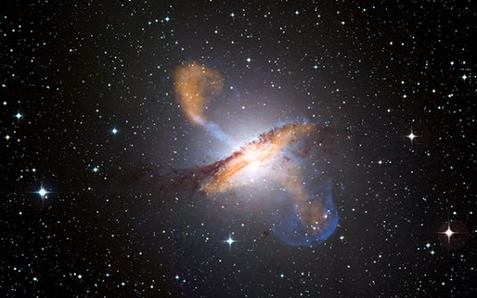
Now, this is a black hole. Centaurus A with jets powered by a supermassive black hole within - the orange jets are as seen in submillimeter by the Atacama Pathfinder and the blue lobes are as seen by the Chandra X-ray space telescope. Credit: NASA/Chandra.
Special relativity allows you to calculate transformations from your proper mass (as well as proper length, proper volume, proper density etc) as your relative velocity changes. So, it is certainly possible to find a point of reference from which your relativistic mass (length, volume, density etc) will seem to mimic the parameters of a black hole.
But a real black hole is a different story. Its proper mass and other parameters are already those of a black hole – indeed you won’t be able to find a point of reference where they aren’t.
A real black hole is a real black hole – from any frame of reference.
(I must acknowledge my Dad, Professor Graham Nerlich, Emeritus Professor of Philosophy, University of Adelaide and author of The Shape of Space, for assistance in putting this together).

Gravity, Schmavity
February 28, 2010
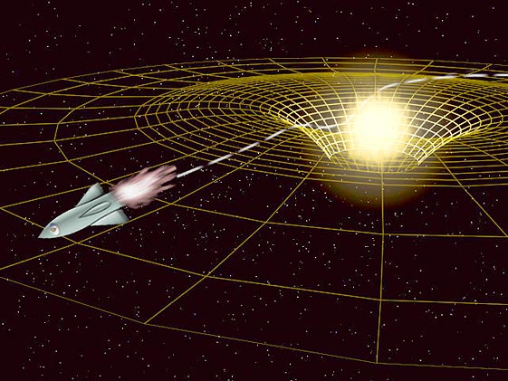
The funny thing about gravity is that unless you come into contact with a solid surface of a massive object you will hardly notice it exists. An external observer might notice that your trajectory gets bent - but that's about it. Credit: NASA.
The axiom that what goes up must come down doesn’t apply to most places in the universe, which are largely empty space. For most places in the universe, what goes up just goes up. On Earth, the tendency of upwardly-mobile objects to reverse course in mid-flight and return to the surface is, to say the least, remarkable.
It’s even more remarkable if you go along for the ride.
If you launch in a rocket you will be pushed back into your seat as long as your rockets fire. But as soon as you cut the engines, you will experience weightlessness as you arc around and fall back down again, following a similar path that a cannon ball fired up from the Earth’s surface would take. And remarkably, you will continue to experience weightlessness all the way down – even though an external observer will observe your rocket steadily accelerating as it falls.
Now consider a similar chain of events out in the microgravity of space. Fire your rocket engines and you’ll be pushed back into your seat. But as soon as you switch them off, the rocket ship will coast at a constant velocity and you’ll be floating in free fall within it – just like you do when plummeting to your accelerated doom back on Earth.
From your frame of reference – and let’s say you’re blind-folded – you would have some difficulty distinguishing between the experience of following a rocket-blast-initiated parabolic trajectory in a gravity field versus a rocket-blast-initiated straight line trajectory out in the microgravity of space. OK, you’ll notice something when you hit the ground in the former case – but you get the idea.
So there is good reason to be cautious about referring to the force of gravity. It’s not like an invisible elastic band that will pull you back down as soon as you shut off your engines. If you were blindfolded, with your engines shut off, it would seem as if you were just coasting along in a straight line – although an external observer in a different frame of reference would see your ship turn about and then accelerate down to the ground.
So how do we account for the acceleration that you the pilot can’t feel?
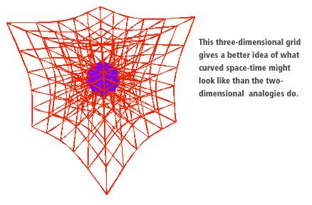
An improvement on the standard two dimensional rubber sheet analogy for curved space-time - although it still fails to fully illustrate the contribution of the all-important time dimension.
Without a blindfold, you the pilot might find the experience of falling in a gravity field a bit like progressing through a slow motion movie – where each frame of the movie that you move through is running at a slightly slower rate than the previous frame. Not only that, but the spatial dimensions in each frame progressively shrink. So, as you move frame by frame, each time taking with you the initial conditions of the previous frame, your initially constant velocity becomes faster and faster, relative to each successive frame that you move through – even though from your perspective you are maintaining a constant velocity.
So – no force of gravity, it’s just geometry.

4. The Universe

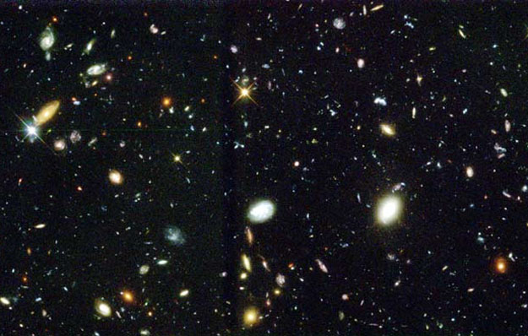
What do you get if you point the Hubble Space Telescope at a bare patch of the night sky and magnify the heck out of it? A snapshot of some of the Universe's 80 billion galaxies. Credit: NASA/Hubble Ultra Deep Field.

As a clear indication that we humans really don't know bleep, the standard model for cosmology (Lambda-Cold Dark Matter) requires that 96% of the universe is composed of invisible mysteries.
About two thirds of the 96% can’t possibly be matter since it apparently grows as the universe grows – so we call it dark energy. More than likely it's not really energy, but we always feel more comfortable if we can put names to things.
The remaining component of the 96% we call dark matter – which we think is a component of the dark side that has been around since shortly after the Big Bang. This dark matter is needed to explain the large scale structure of things. The way that galaxies and galactic clusters hold together really does suggest that most of their mass is invisible.
In 1998, it was confirmed that the universe was expanding with a uniform acceleration. To an outsider, it might seem odd that this discovery suddenly led to the declaration of a mysterious energy, when we had already known for decades prior that the universe was expanding. We had any clear explanation for why it was expanding even before we found out about the acceleration business.
But this is science at work. We've got the data to show that something is going on. So we keep chipping away at the things that we can chip away at, and we identify black boxes that we know have got something inside them, we just don't know exactly what. So here are some stories about the things that we can chip away at. We'll cover the black boxes in the next section.

The Edge of Greatness
December 18, 2010
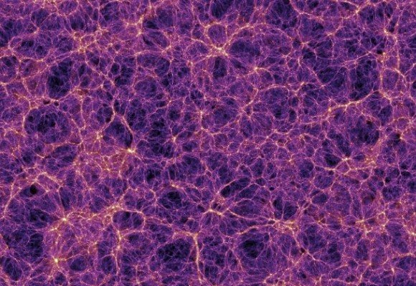
The cosmic web – at this scale we run out of superlatives to describe the large scale structure of the universe. Credit: NASA.
The so-called End of Greatness is where you give up trying to find new words for big when describing large scale objects in the universe. Currently the Sloan Great Wall – a roughly organized collection of galactic superclusters that form a partition between one great void and another great void – is about where most cosmologists draw the line.
Beyond the End of Greatness, it’s best just to consider the universe as a holistic entity. At this scale we consider it to be isotropic and homogeneous, which we need to do to make our current cosmology math work. But at the very edge of greatness, we find the cosmic web.
The cosmic web is not a thing we can directly observe since its 3D structure is derived from redshift data that indicate the relative distances of galaxies from us. When you put this together with their observed positions in the sky the resulting 3D structure seems like a complex web of galactic cluster filaments interconnecting at supercluster nodes – all of which is interspersed by huge voids. These voids are bubble-like – so that we talk about structures, like the Sloan Great Wall, as being the outer surface of such bubbles. And we also talk about the whole cosmic web being ‘foamy’.
It is speculated that the great voids or bubbles, around which the cosmic web seems to be organized, formed out of tiny dips in the primordial energy density (which can be detected in the cosmic microwave background), although this remains pure speculation to date.
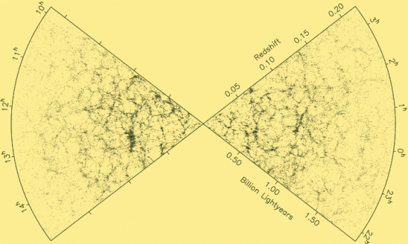
The two degree field (2df) galaxy redshift survey – which used an instrument with a field of view of two degrees, although the survey covered 1500 square degrees of sky in two directions. The wedge shape results from the 3D nature of the data - where there are more galaxies the farther out you look. The foamy bubbles of the cosmic web are visible. Credit: The Australian Astronomical Observatory.
As you may be aware, the Andromeda Galaxy is on a collision course with the Milky Way and the two galaxies are expected to collide in about 4.5 billion years. Each galaxy has its own proper motion in space-time, which it is likely to continue to follow despite the underlying expansion of the universe. So, not every galaxy in the universe is rushing away from every other galaxy in the universe – it’s just a general tendency.
It may be that much of the growing separation between galaxies is a result of the void bubbles expanding, rather than equal expansion everywhere. It’s as though once gravity loses its grip between distant structures – expansion (or dark energy, if you like) takes over and that gap begins to expand unchecked – while elsewhere, clusters and superclusters of galaxies still manage to hold together.

Flat Universe
October 15, 2011
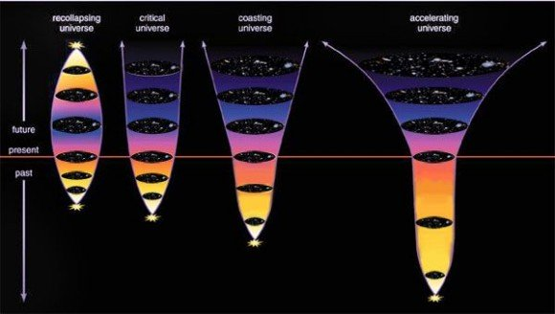
Various universe evolution scenarios. A universe with too much density collapses in on itself, a critical density universe stays static, while a universe with not enough density keeps expanding at a steady (coasting) rate. However, today's cosmology puts emphasis upon the cosmological constant, which gives an accelerating expansion. Does this mean that density is irrelevant? Credit: NASA.
A remarkable finding of the early 21st century, that kind of sits alongside the Nobel prize winning discovery of the universe’s accelerating expansion, is the finding that the universe is geometrically flat. This is a remarkable and unexpected feature of a universe that is expanding – let alone one that is expanding at an accelerated rate – and like the accelerating expansion, it is a key feature of our current standard model of the universe.
It may be that the flatness is just a consequence of the accelerating expansion, but to date this cannot be stated conclusively.
As usual, it’s all about Einstein. The Einstein field equations enable the geometry of the universe to be modeled – and a great variety of different solutions have been developed by different cosmology theorists. Some key solutions are the Friedmann equations, which calculate the shape and likely destiny of the universe via three possible scenarios:
• closed universe – with its contents so dense that the universe’s space-time geometry is drawn in upon itself in a hyper-spherical shape. Ultimately such a universe is destined to collapse in on itself in a big crunch.
• open universe – without sufficient density to draw in space-time, this universe produces an out-flung hyperbolic geometry – commonly called a saddle-shape – its destiny being to expand forever.
• flat universe – with a ‘just right’ density – although an unclear destiny.
The finding, that the universe's geometry was flat, came at about the same time that the universe's accelerating expansion was announced in 1998. The remarkable exactness of the flatness, determined from observations of the cosmic microwave background, left us with a puzzle.
The Friedmann equations assume that the density of the universe's contents, which influence space-time curvature, are key to the universe's large scale geometry. Ball park estimates of the visible matter density of our universe come to around 0.2 atoms per cubic meter, while the relevant part of the Friedmann equations calculated that the critical density required to keep our universe flat is 5 atoms per cubic meter. In other words, we can only find 4% of the required critical density needed to explain the universe's flatness.
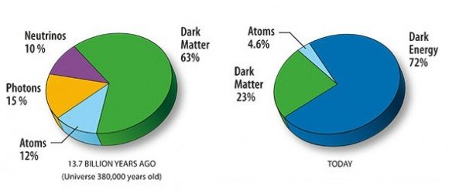
Although the contents of the early universe may have just been matter, we now must add dark energy to explain the universe's persistent flatness. Credit: NASA.
So really, it is the universe’s flatness – and the estimate that we can only see 4% (0.2 atoms per cubic meter) of the matter density required to keep it flat – that drives us to call on dark stuff to explain the universe's geometry. Indeed we can’t just call upon matter, light or dark, to account for how our universe sustains its critical density in the face of expansion, let alone accelerated expansion.
As the universe expands, its contents should become increasingly diluted and hence space-time should be curving hyperbolically. But this is not what we observe - the universe retains its flat geometry despite the ongoing expansion. This seems to be because whatever it is that sustains the critical density seems to be a property of empty space itself. So, we appeal to dark energy to explain this finding – without having a clue about what the heck dark energy is.
Given how little relevance conventional matter appears to have in our universe’s geometry, one might question the continuing relevance of the Friedmann equations in modern cosmology. There is some recent interest in the De Sitter universe, another Einstein field equation solution which models a universe with no matter content – its expansion and evolution being entirely the result of the cosmological constant.
De Sitter universes, at least on paper, can be made to expand with accelerating expansion and they remain spatially flat – much like our universe does. From this, it is tempting to suggest that perhaps all universes naturally stay flat while they undergo accelerated expansion – because that’s what universes do. Perhaps it is the case that the contents of universes have less direct influence on their large-scale geometry, or on their long-term evolution, than we have been assuming.
But who knows really – we are both literally and metaphorically working in the dark on this.
Further reading:
Krauss, L.: Why the universe probably is flat.

One Crowded Nanosecond
September 11, 2010
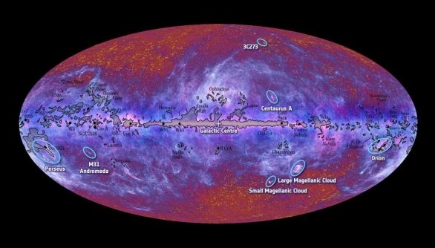
Labeled version of the Planck space observatory's all-sky survey. Over the course of its mission, Planck is expected to deliver more detailed observations of the cosmic microwave background than were achieved by WMAP. Credit: ESA.
Remember how you could once pick up a book about the first three minutes after the Big Bang and be amazed by the level of detail available about those early moments of the universe? These days our focus is more on what happened between 1×10⁻³⁶ and 1×10⁻³² of the first second as we try to marry theory with more detailed observations of the cosmic microwave background.
About 380,000 years after the Big Bang, the early universe became cool and diffuse enough for light to move unimpeded, which it proceeded to do – carrying with it information about the ‘surface of last scattering’. Before this time photons were being continually absorbed and re-emitted (i.e. scattered) by the hot dense plasma of the earlier universe - and never really got going anywhere as light rays.
But quite suddenly, the universe got a lot less crowded when it cooled enough for electrons to combine with nuclei to form the first atoms. So this first burst of light, as the universe became suddenly transparent to radiation, contained photons emitted in that fairly singular moment – since the circumstances to enable such a universal burst of energy only happened once.
Over the ensuing 13 plus billion years, lots of these photons probably crashed into something long ago. But enough are still left over to fill the sky with a signature energy burst, that might have once been blindingly bright, but has now been stretched right out into microwave. Nonetheless, it does still contains that same ‘surface of last scattering’ information.
Observations tell us that, at a certain level, the cosmic microwave background is remarkably isotropic. This led to the cosmic inflation theory, where we think there was a very early exponential expansion of the microscopic universe at around 1×10⁻³⁶ of the first second – which explains why everything appears so evenly spread out.
However, a close look at the cosmic microwave background does show a tiny bit of lumpiness, or anisotropy, as demonstrated in data collected by the aptly-named Wilkinson Microwave Anisotropy Probe (WMAP).
Probably the most remarkable thing about the cosmic microwave background is its large scale isotropy - that is, it looks about the same wherever you look. This is good evidence for a Big Bang followed by rapid cosmic expansion. But with that now well established, finding fine grain anisotropies (slight differences if you look up close) is valuable new data. It gives theorists something to work with as they build mathematical models about the nature of the early universe.
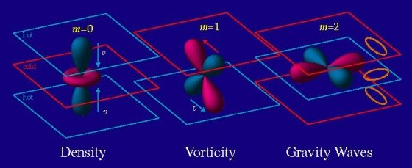
The apparent quadrupole moment anomalies in the cosmic microwave background might result from irregularities in the early universe - including density fluctuations, dynamic movement (vorticity) or even gravity waves. Credit: University of Chicago.
Some theorists speak of quadrupole moment anomalies in the cosmic microwave background. The quadrupole idea relates to the energy density distribution within a spherical volume. This energy density might scatter light in an up-down direction or a back-forward direction (or variations from those four ‘polar’ directions). A small degree of quadrupole deflection in the cosmic microwave background photons provide us with hints of strange features that may have lain within the early universe.
For example, say it was filled with mini black holes?
Scardigli et al (see below) mathematically investigated three scenarios, where just prior to cosmic inflation at 1×10⁻³⁶ seconds:
- the tiny primeval universe was filled with a collection of mini black holes;
- the mini black holes formed but then immediately evaporated, creating multiple point sources of Hawking radiation; or
- there were no mini black holes at all.
When they ran the math, scenario 1 best fits with the WMAP spacecraft’s observations of anomalous quadrupole anisotropies. So, hey – why not? A tiny proto-universe filled with mini black holes. It’s another option to test when some higher resolution cosmic microwave background data comes in from the Planck space observatory or other missions to come. And in the meantime, it’s material for an astronomy writer desperate for a story.
Further reading: Scardigli, F., Gruber,C. and Chen (2010) Black hole remnants in the early universe.

Black Holes: The Early Years
February 19, 2011
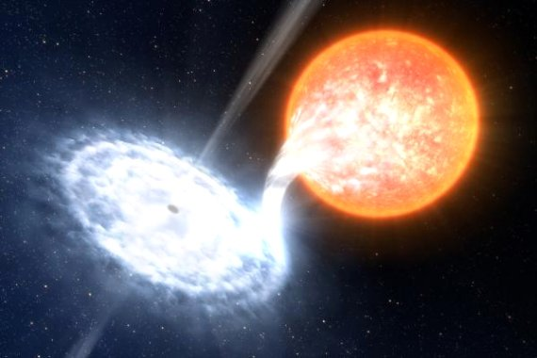
High mass X-ray binaries were probably common in the early universe - and their X-ray emitting black hole components may have shaped the destiny of the later universe. Credit: European Southern Observatory.
There’s a growing view that black holes in the early universe may have been the seeds around which most of today’s big galaxies (now with supermassive black holes within) first grew. And taking a step further back, it might also be the case that black holes were key to reionizing the early interstellar medium – which then influenced the large scale structure of today’s universe.
To recap those early years… First was the Big Bang – and for about three minutes everything was very compact and hence very hot. But after three minutes the first protons and electrons formed and for the next 17 minutes a proportion of those protons interacted to form helium nuclei – until at 20 minutes after the Big Bang, the expanding universe became too cool to maintain nucleosynthesis. From there, the protons and the helium nuclei and the electrons just bounced around for the next 380,000 years as a very hot plasma.
There were photons too, but there was little chance for these photons to do anything much except be formed and then immediately reabsorbed by an adjacent particle in that broiling hot plasma. But at 380,000 years, the expanding universe cooled enough for the protons and the helium nuclei to combine with electrons to form the first atoms. Suddenly the photons were left with empty space in which to shoot off as the first light rays, which today we can still detect as the cosmic microwave background.
And it’s about here that the reionization story starts. The cool, stable hydrogen atoms of the early interstellar medium didn’t stay cool and stable for very long. In a smaller universe full of densely-packed stars, these atoms were quickly reheated, causing their electrons to dissociate and their nuclei to become free ions again. This turned the interstellar medium from a gas back into a low density plasma – although a plasma that was too diffuse to be opaque to light any more.
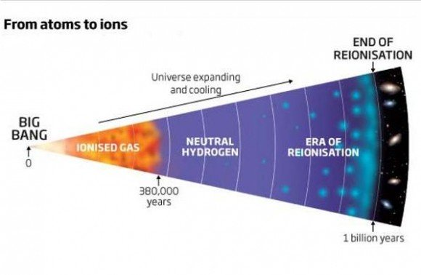
Well, really from ions to atoms to ions again - hence the term reionization. The only difference is that at half a billion years since the Big Bang, the reionized plasma of the interstellar medium was so diffuse that it remained - and still remains - transparent to radiation. Credit: New Scientist.
It is possible that this reionization step then limited the size to which new stars could grow – as well as limiting opportunities for new galaxies to grow – since hot, excited ions are less likely to aggregate and accrete than cool, stable atoms. Indeed, reionization may have contributed to the current ‘clumpy’ distribution of matter – which is organized into generally large, discrete galaxies rather than an even spread of stars everywhere.
And it’s been suggested that early black holes may have made a significant contribution to the reionization of the early universe. Computer modeling suggests that the early universe, with a tendency towards very massive stars, would be much more likely to have black holes as stellar remnants, rather than neutron stars or white dwarfs. Also, those black holes would more often be in binary systems than in isolation (since massive stars more often form multiple systems than do small stars).
So with a massive binary where one component is a black hole, the black hole will be likely to accumulate a large accretion disk composed of matter drawn from the other star. Then that accretion disk will begin to radiate high energy photons, particularly at X-ray energy levels.
While the number of ionizing photons emitted by an accreting black hole is probably similar to that of its bright, luminous progenitor star, it would be expected to emit a much higher proportion of high energy X-ray photons – with each of those photons potentially heating and ionizing multiple atoms in its path, while a luminous star’s photon’s might only reionize one or two atoms.
So there you go. Black holes… is there anything they can’t do?
Further reading: Mirabel et al Stellar black holes at the dawn of the universe.

Secular Evolution
December 25, 2010
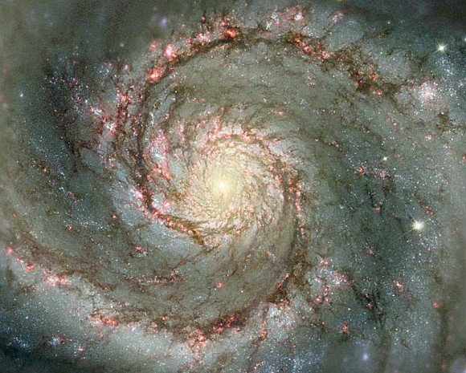
M51 - the Whirlpool Galaxy. Like most spiral galaxies, the spiral arms are really density waves. Drag forces produced by these density waves could drive the 'secular' evolution of galaxies. Credit: NASA/Hubble Space Telescope.
A traditional galaxy evolution model has it that you start with spiral galaxies – which might grow in size through digesting smaller dwarf galaxies, but otherwise retain their spiral form relatively undisturbed. It is only when these galaxies collide with another of similar size that you first get a ‘train-wreck’ irregular form - and this then eventually settles into a featureless elliptical form – full of stars following random orbital paths rather than moving in the same narrow orbital plane that we see in the flattened galactic disk of a spiral galaxy.
The concept of secular galaxy evolution challenges this notion – where ‘secular’ means separate or isolated. Theories of secular evolution propose that galaxies naturally evolve along the Hubble sequence (from spiral to elliptical forms), without merging or collisions necessarily driving changes in their form.
While it’s clear that galaxies do collide – and then generate the many irregular galaxy forms we can observe – it is conceivable that the shape of an isolated spiral galaxy could evolve towards a more amorphously-shaped elliptical galaxy if it possessed a mechanism to transfer angular momentum outwards.
The flattened disk shape of a standard spiral galaxy results from spin – presumably acquired during its initial formation. Spin will naturally cause an aggregated mass to adopt a disk shape – much as pizza dough spun in the air will form a disk. Conservation of angular momentum requires that the disk shape will be sustained indefinitely unless the galaxy can somehow lose its spin. This might happen through a collision – or otherwise by transferring mass, and hence angular momentum, outwards. This is analogous to spinning skaters who fling their arms outwards to slow their spin.
Density waves may be significant here. The spiral arms commonly visible in galactic disks are not static structures, but rather density waves which cause a temporary bunching together of orbiting stars. These density waves may be the result of orbital resonances generated amongst the individual stars of the disk.
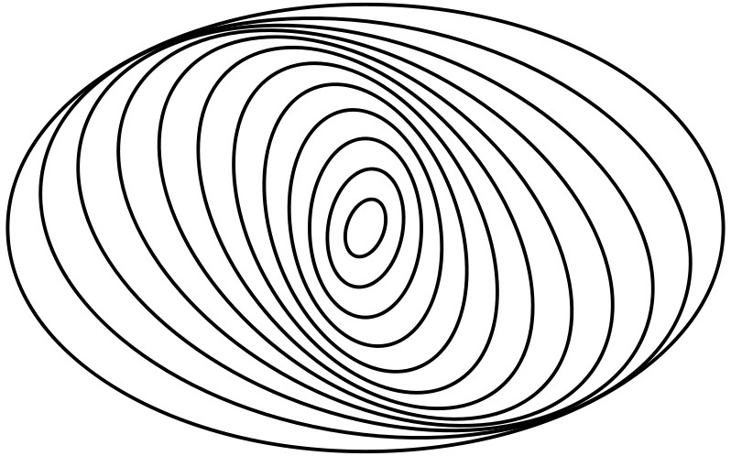
The spiral arms of spiral galaxies are thought to result from resonances that build up between the orbits of adjacent stars and clusters that are moving around the galaxy. Thus, the arms we see are not really permanent structures, but areas where stars and clusters are temporarily slowed up and bunched together before they move on again in their orbits. Credit: Wikimedia.
It has been suggested that a density wave represents a collision-less shock which has a damping effect on the spin of the disk.
A galactic disk has a corotation radius – a point where stars rotate at the same orbital velocity as the density wave (i.e. what is perceived as a spiral arm). Within this radius, stars move faster than the density wave – while outside the radius, stars move slower than the density wave.
This may account for the spiral shape of the density wave, as well as offering a mechanism for the outward transfer of angular momentum. Within the radius of corotation, stars are giving up angular momentum to the density wave as they push through it – and hence push the wave forward. Outside the radius of corotation, the density wave is dragging through a field of slower moving stars – giving up angular momentum to them as it does so.
The result is that the outer stars are flung further outwards to regions where they could adopt more random orbits, rather than being forced to conform to the mean orbital plane of the galaxy. In this way, a tightly-bound rapidly-spinning spiral galaxy could gradually evolve towards a more amorphous elliptical shape.
Further reading: Zhang and Buta. Density-Wave Induced Morphological Transformation of Galaxies along the Hubble Sequence.

5. Known unknowns

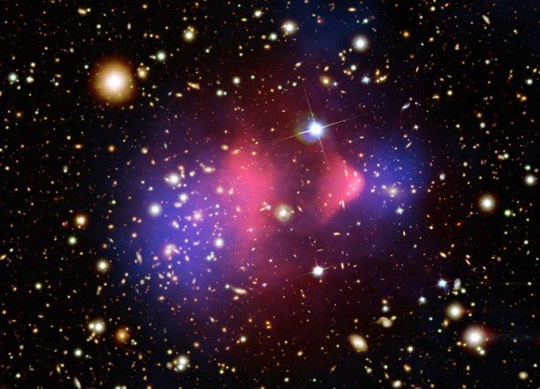
When galaxies collide. The Bullet Cluster is the aftermath of a collision between two separate galactic clusters. The (false color) blue regions may be dark matter - since they have significant mass causing gravitational lensing of the galaxies behind, but otherwise their contents are invisible and cold. The (also false color) red regions are more familiar hot intergalactic gases, mostly hydrogen.
It is thought that two clusters approached from the right and left of the frame and then collided. The normal (red) matter of each cluster (being strongly interactive) has been caught up in the middle of the collision and shows signs of a shock wave generated by that collision. However, the dark (blue) matter contents of each cluster (being weakly interactive) has just ploughed straight through and out the other side.

The Schrödinger’s cat thought experiment is a good way to assess people's willingness to entertain extraordinary claims. It seems quite reasonable to propose that there is a 50/50 chance that the cat in the box will live or die and that the outcome can only be confirmed by observing it. It seems quite extraordinary to propose that the cat exists in that box in two indeterminate live and dead states until the outcome is observed. Schrödinger didn't think much of this idea either - his cat story was intended to ridicule the whole notion.
The frustrating aspect of the two indeterminate states theory is that you can't readily prove or disprove it since the two indeterminate states collapse into one determinant state as soon as you go to observe what's there. How convenient.
Building our understanding of reality upon hypotheses of the unknowable is a perplexing path to follow, but 21st century science seems determined to give it a go. These stories outline what is known and unknown about the unopened boxes upon which we build our current understanding of the universe. No doubt history will confirm some claims and dismiss others, as we collect more evidence about what's really out there (or in there).

Is Time Real?
June 12, 2010
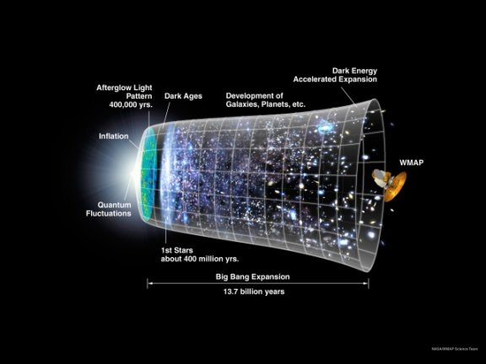
The whole ball game. The Universe got very big, very early, and then its spatial three-dimensional growth was roughly linear for a while. But more recently, this growth has begun accelerating. And this entire sequence of events has occurred within a fourth dimension that we call time. Credit: Wikimedia.
Time is an illusion caused by the passage of history (Douglas Adams 1952-2001).
The way that we look at time is central to a major, current schism in physics. Under classic Newtonian physics and also quantum mechanics time is absolute, a universal metronome allowing you to determine whether events occur simultaneously or in sequence. Under Einstein’s physics, time is not absolute – simultaneity and sequence depend on who’s looking. For Einstein, the speed of light (in a vacuum) is absolute and constant and time varies in whatever way is required to keep the speed of light constant from all frames of reference.
Under general relativity you are able to experience living for three score and ten years regardless of where you are or how fast you’re moving, but other folk might measure that duration quite differently. For example, if you happen to be falling into a black hole, or otherwise orbiting the Earth at 99% of the speed or light – to an outside observer you might appear to be ageing for a lot longer than three score and ten years.
Quantum mechanics does require absolute time (well, sometimes) – most obviously in regards to quantum entanglement, where determining the spin of one particle determines the spin of its entangled partner, instantaneously and simultaneously. Leaving aside the baffling conundrum of this instantaneous action over a distance, the simultaneity of the event requires the existence of absolute time.
In one attempt to reconcile general relativity and quantum mechanics, time disappears altogether – from the Wheeler-DeWitt equation for quantum gravity – not that many regard this as a very successful attempt at reconciliation.
Time keeps on slippin' into the future (The Steve Miller Band)
In any case, this line of thinking highlights the ‘problem of time’ when trying to develop a 'theory of everything' that reconciles general relativity and quantum mechanics. The winning entries for an essay competition on the nature of time run by the Fundamental Questions Institute could be roughly grouped into the themes ‘time is real’, ‘no, it isn’t’ and ‘either way, it’s useful so you can cook dinner.’
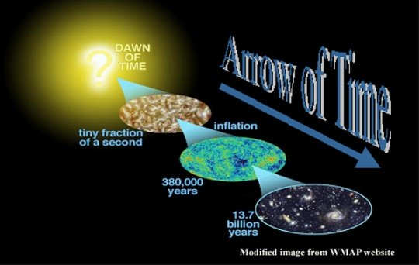
How a return to equilibrium after a random downward fluctuation in entropy might appear. First there was light, then a whole bunch of stuff happened and then it started getting cold and dark and empty. Credit: NASA.
Time is the fire in which we burn (Soran - Star Trek bad guy, circa 24th century).
The 'time is real' proponents more often sit within the Einstein camp - viewing time as an inseparable aspect of the four dimensional fabric of the universe (i.e. space-time).
The ‘time isn’t real’ camp runs the line that time is just a by-product of what the universe does (anything from the Earth rotating to the transition of a Cesium atom – i.e. the things that we calibrate our clocks to).
‘Time isn’t real’ proponents also refer to Boltzmann’s attempt to trivialize the arrow of time. Boltzmann proposed that we just live in a local pocket of the universe, where there has been a random downward fluctuation of entropy. Hence, the perceived forward arrow of time is a result of the universe returning to equilibrium – being a state of higher entropy where it’s very cold and most of the transient matter that we live our lives upon has evaporated. Boltzmann suggests it is conceivable that an upward fluctuation in entropy might just as easily occur within a different region of the wider universe, making the arrow of time point the other way in that region.
Nearly everyone agrees that time probably doesn’t exist outside our Big Bang universe – and the people who just want to get on and cook dinner suggest we might concede that space-time could be an emergent property of quantum mechanics. If so, we just need to rejig the math, perhaps after dinner.

Bubblology
July 23, 2011
Multiverse hypotheses suggest that bubble universes should eventually interact and we should be able to determine the existence of the multiverse from such interactions. Credit: cosmology.com
One model of a hypothetical multiverse has, perhaps appropriately, some similarity to a glass of beer. Imagine an eternal false vacuum. It is a bit like a fluid, though not all that much like a fluid – since it doesn’t have volume. In fact it doesn’t have any spatial dimensions. Then imagine that this eternal false vacuum expands.
This may sound rather contradictory since expansion implies there are spatial dimensions, but a string theorist will assure you that it all happens at the sub-Planck scale, where lots of immeasurable and unknowable things can happen – and after a few more drinks you might be willing to go along with this.
So – next, we introduce bubbles into the false vacuum. The bubbles – which are essentially independent baby universes – are true vacuums and can rationally and reasonably expand since they have four overt dimensions of space-time – albeit they may also have the other immeasurable and unknowable dimensions in common with the encompassing false vacuum.
The bubbles are the reason why it is necessary for the false vacuum to expand, indeed it must expand faster than the bubbles – otherwise an expanding bubble universe could ‘percolate’ – that is, spread throughout the all-encompassing false vacuum – so that your multiverse would just become a universe. And where’s the fun in that?
Anyhow, within such an eternal expanding fluid, bubble universes may nucleate at random points – taking us away from the coffee analogy and back to the beer. In bubblology terms, nucleation is the precursor of inflation. The sub-Planck energy of the non-dimensional false vacuum occasionally suffers a kind of hiccup – perhaps a quantum tunneling event – making the sub-Planck virtual nothingness commence a slow roll down a potential energy hill (whatever the heck that means).
At a certain point in that slow roll, the energy level shifts from a sub-Planck potential-ness into a supra-Planck actual-ness. This shift from sub-Planck to supra-Planck is thought to be a kind of phase transition from something ephemeral to a new ground state of something lasting and substantial – and that phase transition releases heat, kind of like how the phase transition from water to ice releases latent heat.
And so you get the production of a gargantuan amount of energy out of nothing, which we have chosen to call the Big Bang. The energy drove the exponential cosmic inflation of our own bubble universe and that inflation diluted the energy density within the bubble so that it became cool enough to form matter.
So it was that a bubble of persistent somethingness formed from within the eternal beer of nothingness.
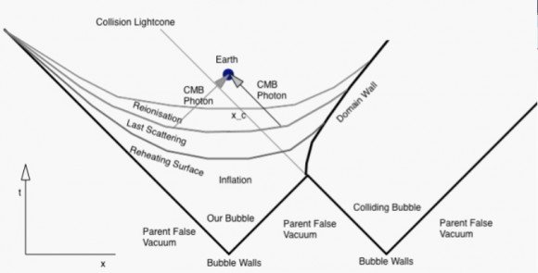
The light cone of our bubble universe showing the stages of the energy release driving cosmic inflation (reheating), the surface of last scattering (recombination) and the subsequent dissolution of the cosmic fog (reionization) - cosmic microwave background photons from the surface of last scattering could show signs of a collision with an adjacent bubble universe. Credit: Kleban.
Good story, huh? But, where’s the evidence? Well, there is none, but despite the usual criticisms lobbed at string theorists this is an area where they attempt to offer testable predictions.
Within a multiverse, one or more collisions with another bubble universe are almost inevitable given the beer-mediated timeframe of eternity. Such an event may yet lie in our future, but could equally lie in our past – the fact that we are still here indicating (anthropically) that such a collision may not be fatal.
A collision with another bubble might pass unnoticed if it possessed exactly the same cosmological constant as ours and its contents were roughly equivalent. The bubble wall collision might appear as a blueshifted circle in the sky – perhaps like the Cold Spot in the cosmic microwave background, although this is most likely the result of a density fluctuation within our own universe.
We could be in trouble if an adjacent universe’s bubble wall pushed inwards on a trajectory towards us – and if it moved at the speed of light we wouldn’t see it until it hit. Even if the wall collision was innocuous, we might be in trouble if the adjacent universe was filled with antimatter. It’s these kind of factors that determine what we might observe – and whether we might survive such an, albeit hypothetical, event.
Further reading: Kleban. Cosmic bubble collisions.

Our Inferred Universe
April 2, 2011
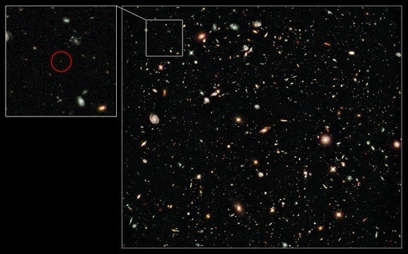
A galaxy far, far away and long, long ago. UDFy-38135539 - about the most distant observed object, where UDF stands for (Hubble) Ultra-Deep Field. Credit: NASA/Hubble Space Telescope and ESA.
The universe is a big place – and getting bigger all the time – so at a large scale all unbound structures are all moving away from each other. So when we look out at distant objects, we need to remind ourselves that not only are we seeing them as they appeared in the past, but also that they are no longer in the location where we are seeing them.
This issue reaches an extreme when we consider observations of the first luminous stars and galaxies – with the galaxy UDFy-38135539 currently holding the record as the most distant object observed and one of the youngest, existing 13.1 billion years ago – although UDFj-39546284 may be the next contender at 13.2 billion years old, subject to further spectroscopic confirmation.
UDFy-38135539 has a red-shift (z) of 10 and provides no measurable light at visible wavelengths. Although light from it took 13.1 billion years to reach us – it is not correct to say that it is 13.1 billion light years away. In that intervening period, both it and we have moved further away from each other.
So not only is it now further away than it appears, but when the light that we see now was first emitted, it was much closer than 13.1 billion light years. For this reason it appears larger than an object 13.1 billion light years away should look. But it also looks dimmer because the light carrying its image has been stretched out (red-shifted) by the intervening expansion of the universe.
So we need to clarify UDFy-38135539′s distance as a comoving distance (calculated from its apparent distance and the assumed expansion rate of the universe). This calculation would represent the proper distance between us and it – as if a tape measure could be used the measure that distance right now.
This distance works out to be about 30 billion light years. But we are just guessing that UDFy-38135539 still exists – more likely it has merged with other young galaxies – perhaps becoming part of a huge spiral galaxy similar to our own Milky Way, which itself contains stars that may be over 13 billion years old.
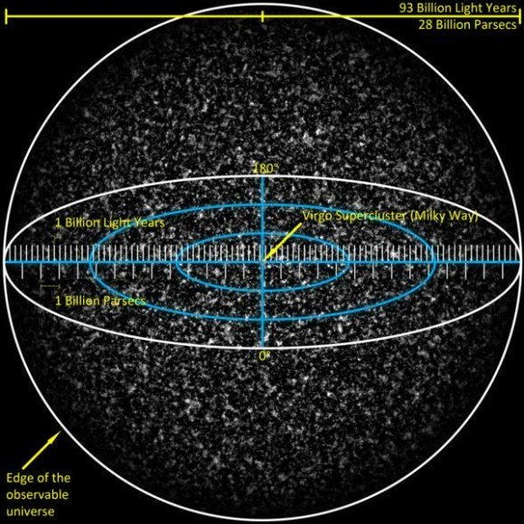
The observable, or inferred, universe with a diameter of 93 billion light years. Even this may just be a small component of the whole ball game. At this scale, our vast galactic neighborhood, the Virgo Supercluster, is too small to be seen. Credit: Azcolvin429.
It is generally said that the comoving distance to the particles that emitted the cosmic microwave background is about 45.7 billion light years away – even though the photons those particles emitted have only been traveling for nearly 13.7 billion years. Similarly, by inference, the absolute edge of the observable universe is 46.6 billion light years away.
However, you can’t conclude that this is the actual size of the universe – nor should you conclude that the cosmic microwave background has a distant origin. Your coffee cup may contain particles that originally emitted the cosmic microwave background – and the photons they emitted may be 45.7 billion light years away now – perhaps just now being collected by alien astronomers who will hence have their own 46.6 billion light year radius universe to infer – most of which they can’t directly observe either.
All universal residents have to infer the scale of the universe from the age of the photons that come to us and the other information that they carry. And this will always be historical information.
From Earth we can’t expect to ever come to know about anything that is happening right now in objects that are more distant than a comoving distance of around 16 billion light years, this being the cosmic event horizon (equivalent to a redshift of around z = 1.8).
This is because those objects are right now receding from us at faster than the speed of light. We may still continue receiving updated historical data about them for many billions of years to come – until they become so redshifted as to appear to wink out of existence. But really, they are already lost to us.
Further reading: Davis and Lineweaver. Expanding Confusion: common misconceptions of cosmological horizons and the superluminal expansion of the universe.

Assumptions
April 17, 2011
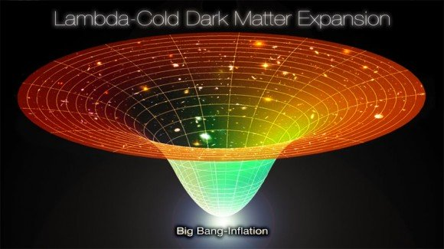
The Lambda-Cold Dark Matter model attempts to describe the entire universe by assuming that the entire universe is both isotropic and homogeneous. This assumption equally applies to the past, present and future - incorporating a single originating Big Bang event, a current flat geometry and a future dominated by accelerating expansion - here, there and everywhere. Credit: Anon, sourced from coldcreation.blogspot.com
The current standard model of the universe, Lambda-Cold Dark Matter, assumes that the universe is expanding in accordance with the geometrical term Lambda – which represents the cosmological constant used in Einstein’s general relativity. Lambda might be assumed to represent dark energy, a mysterious force driving what we now know to be an accelerating expansion of space-time. Cold dark matter is then assumed to be the scaffolding that underlies the distribution of visible matter at a large scale across the universe.
But to make any reasonable attempt at modeling what the universe is like now – and what it was like in the past and how it will be in the future – we first have to assume that it is roughly the same everywhere.
This is sometimes called the Cosmological Principle, which states that when viewed on a sufficiently large scale, the properties of the Universe are the same for all observers. This captures two concepts – that of isotropy, which means that the universe looks roughly the same anywhere you (that is you) look – and homogeneity, which means the universe looks roughly the same for any observers – anywhere they are and anywhere they look. Homogeneity is not something we can expect to ever confirm by observation – so we must assume that the part of the universe we can directly observe is a fair and representative sample of the rest of the universe.
An assessment of isotropy can be made by looking down into our past light-cone. In other words, we look out into the universe and receive historical information about how it behaved in the past. We then assume that those parts of the universe we can observe have continued to behave in a consistent and predictable manner up until the present – even though we can’t confirm whether this is true until more time has passed. But anything outside our light cone is not something we can expect to ever know about and hence we can only ever assume the universe is homogeneous throughout.
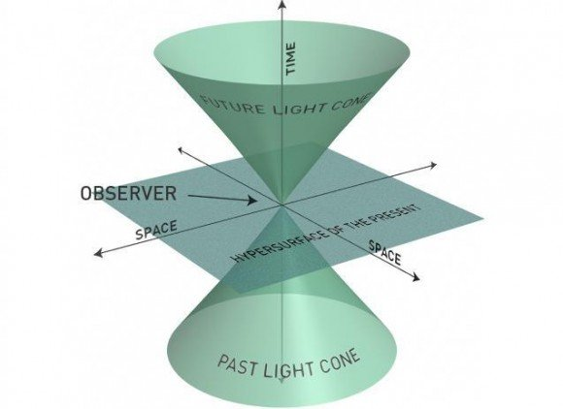
From your position in space-time you can observe anything that has happened within your past light cone - you just have to keep reminding yourself that what you are observing 'now' actually happened in the past. You can also shine a torch beam forwards towards a future universe - knowing that one day it might reach any object that lies in your future light cone. However, you can't directly observe anything that is happening right now at a distant position in space - because it lies on the 'hypersurface of the present'. Credit: Aainsqatsi.
A South African astrophysicist, Roy Maartens has a go at developing an argument as to why it might be reasonable for us to assume that the universe is homogeneous. Essentially, if the universe we can observe shows a consistent level of isotropy over time, this strongly suggests that our bit of the universe has unfolded in a manner consistent with it being a part of a homogenous universe.
The isotropy of the observable universe can be strongly implied if you look out in any direction and find:
- consistent matter distribution;
- consistent bulk velocities of galaxies and galactic clusters moving away from us via universal expansion;
- consistent measurements of angular diameter distance (where objects of the same absolute size look smaller at a greater distance – until a distance of redshift 1.5, when they start looking larger – see here); and
- consistent gravitational lensing by large scale objects like galactic clusters.
These observations support the assumption that both matter distribution and the underlying space-time geometry of the observable universe is isotropic. If this isotropy is true for all observers, then the universe is consistent with the Friedmann–Lemaître–Robertson–Walker (FLRW) metric.
This would mean it is homogeneous, isotropic and connected – so you can travel anywhere within it (simple connected) – or it might even have wormholes so not only can you travel anywhere in it, but there are short cuts (multiple connected).
That the observable universe has always been isotropic – and is likely to continue being so into the future – is strongly supported by observations of the cosmic microwave background, which is isotropic down to a fine scale. If this same isotropy is visible to all observers, then it is likely that the universe has been, is and will always be homogeneous as well.
Finally, Maartens appealed to the Copernican Principle – which says that not only are we not the center of the universe, but our position is largely arbitrary. In other words, the part of the universe we can observe may well be a fair and representative sample of the wider universe.
Further reading: Maartens Is the universe homogeneous?

Black Hole Entropy
March 12, 2011
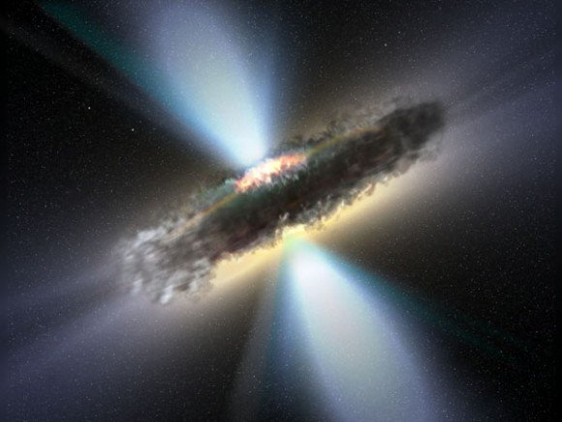
Black holes - throw something in them and that's the end of the story, right? Well, apparently some physicists just can't leave it there. Credit: NASA.
An easy way to think about the entropy of black holes is to consider that entropy represents the loss of free energy – that is, energy that is available to do work – from a system. Needless to say, anything you throw into a black hole is no longer available to do work.
An easy way to understand the second law of thermodynamics (which is the one about entropy) is to consider that heat can’t flow from a colder location to a hotter location – it only ever flows the other way. As a result, any isolated system should eventually achieve a state of thermal equilibrium. Or, if you like, the entropy of an isolated system will tend to increase over time – achieving a maximum value when that system achieves thermal equilibrium.
If you express entropy mathematically, it is a calculable value that naturally increases over time. In the seventies, Jacob Bekenstein expressed black hole entropy as a problem for physics. If you suddenly transfer a system with a known entropy value past the event horizon of a black hole, it becomes immeasurable – as though its entropy has been removed from the universe. This represents a violation of the second law of thermodynamics – since the entropy of a system (or a universe) should at best stay constant – it can’t suddenly plummet like that.
One solution to the black hole entropy problem is to assume that anything that falls into a black hole adds to the entropy of the black hole. This then gives us another reason why black holes can be considered to have a very high entropy.
You can also define entropy in terms of information. The sentence The quick brown fox jumps over the lazy dog is a highly engineered system with a low level of entropy – while drawing out 35 tiles from a scrabble set and laying them down however they come delivers a randomly ordered object with a high level of entropy.
If you throw your scrabble tiles into a black hole, they will carry with them whatever entropy value that they began with. There is a fundamental principle in quantum mechanics which requires that information can neither be destroyed or lost. It’s actually more about wave functions than it is about scrabble tiles – but let’s stick with the analogy.
You won’t violate the conservation of information principle by filling a black hole with scrabble tiles. Their information is just transferred to the black hole rather than being lost – and even if the tiles are crushed to bits, the information is still there in some form. This is not a problem.
There is a problem if, in a googol or so years, the black hole evaporates via Hawking radiation. Hawking radiation arises from quantum fluctuations at the event horizon and has no immediate causal connection with the contents of the black hole.
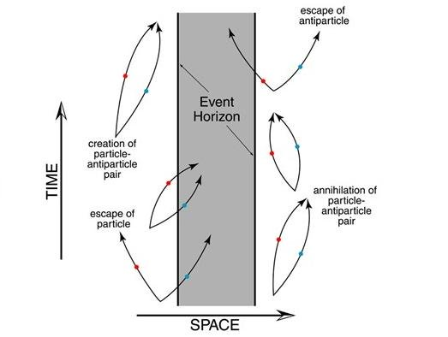
The Hawking radiation story. A quantum fluctuation proximal to a black hole's event horizon produces a particle and an antiparticle. The antiparticle enters the black hole and annihilates when it collides with a particle in there. The remaining particle is free to join the rest of the universe outside the event horizon. To an external observer, the black hole appears to have lost mass and radiated a particle. Over time this process would result in the black hole evaporating. To date - good story, nil evidence, but watch this space. Credit: NAU.
This means that Hawking radiation presents a new problem where a black hole storing information and entropy can evaporate - violating the principles of conservation of information and conservation of entropy.
A currently favored solution to the information part of this problem is the holographic principle – which suggests that whatever enters the black hole leaves an imprint on its event horizon – such that information about the entire contents of the black hole can be derived from just the event horizon ‘surface’. This means that any subsequent Hawking radiation is influenced at a quantum level by the information imprinted on the black hole's event horizon 'surface' – such that Hawking radiation does succeed in carrying information out of the black hole as the black hole evaporates.
Zhang et al approach the problem from an different angle by suggesting that Hawking radiation carries entropy out of the black hole via quantum tunneling. And since reduced entropy means reduced uncertainty – this represents a net gain in information that is drawn out from the black hole.
But is this more or less convincing than the hologram idea? Well, we need more information.
Further reading: Zhang et al. An interpretation for the entropy of a black hole.

What Can The Dark Matter Be?
March 1, 2010
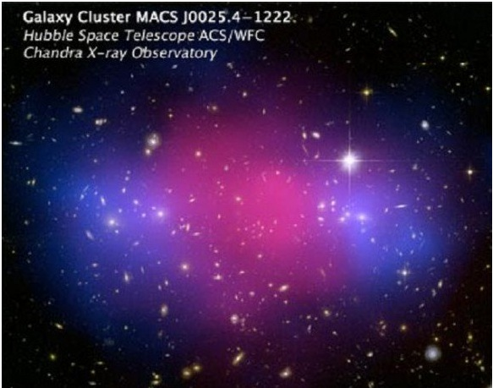
Similar to the Bullet Cluster, MACS J0025.4-1222 represents the aftermath of the collision of two galaxy clusters. Most of the mass of each cluster remnant is in the cool blue regions - each having already moved beyond the collision point due to being only weakly interacting mass. The pink region represents strongly radiating and strongly interacting mass that has been slowed up within the initial collision. Credit NASA.
What better place to look for dark matter than down a mine shaft? A research team from the University of Florida have spent nine years monitoring for any signs of the elusive stuff using germanium and silicon detectors cooled down to a fraction of a degree above absolute zero. And the result? A couple of maybes and a gritty determination to keep looking.
The case for dark matter can be appreciated by considering the solar system. To stay in orbit around the Sun, Mercury has to move at 48 kilometers a second, while distant Neptune can move at a leisurely 5 kilometers a second. Surprisingly, this principle doesn’t apply in the Milky Way or in other galaxies we have observed. Broadly speaking, you can find stuff in the outer parts of a spiral galaxy that is moving just as fast as stuff that is close in to the galactic centre. This is puzzling, particularly since there doesn’t seem to be enough gravity in the system to hold onto the rapidly orbiting stuff in the outer parts – which should just fly off into space.
So, we need more gravity to explain how galaxies rotate and stay together – which means we need more mass than we can observe. This is why we invoke dark matter. Invoking dark matter also helps to explain why galaxy clusters stay together and explains instances of gravitational lensing effects where there isn't enough visible mass to cause such lensing.
Computer modeling suggests that galaxies may have dark matter halos, but they also have dark matter distributed throughout their structure – and taken together, all this dark matter represents up to 90% of a galaxy’s total mass.
An artist's impression of dark matter, showing the proportional distribution of baryonic and non-baryonic forms (this joke never gets old).
Current thinking is that a small component of dark matter is baryonic, meaning stuff that is composed of protons and neutrons – in the form of cold gas as well as dense, non-radiant objects such black holes, neutron stars, brown dwarfs and orphaned planets (known as Massive Astrophysical Compact Halo Objects or MACHOs).
But it doesn’t seem that there is nearly enough dark baryonic matter to account for the circumstantial evidence of dark matter's existence. Hence we have concluded that most dark matter must be non-baryonic, in the form of Weakly Interacting Massive Particles (or WIMPs).
By inference, WIMPS are transparent and non-reflective at all wavelengths and presumably have neutral charge. Neutrinos, which are produced in abundance from the fusion reactions of stars, would fit the bill nicely except they don’t have enough mass. One possible WIMP candidate is a neutralino, a hypothetical particle predicted by supersymmetry theory.
The second Cryogenic Dark Matter Search Experiment (or CDMS II) runs deep underground in the Soudan iron mine in Minnesota, so situated that it will only intercept particles that can penetrate that deeply underground. The CDMS II solid crystal detectors seek ionization and phonon events which can be used to distinguish between electron interactions and nuclear interactions. It is assumed that a dark matter WIMP particle will ignore electrons, but potentially interact with (i.e. bounce off) a nucleus.
Two possible events have been reported by the University of Florida team, who acknowledge their findings cannot be considered statistically significant, but may at least give some scope and direction to further research. And so the search continues.

6. Out of left field
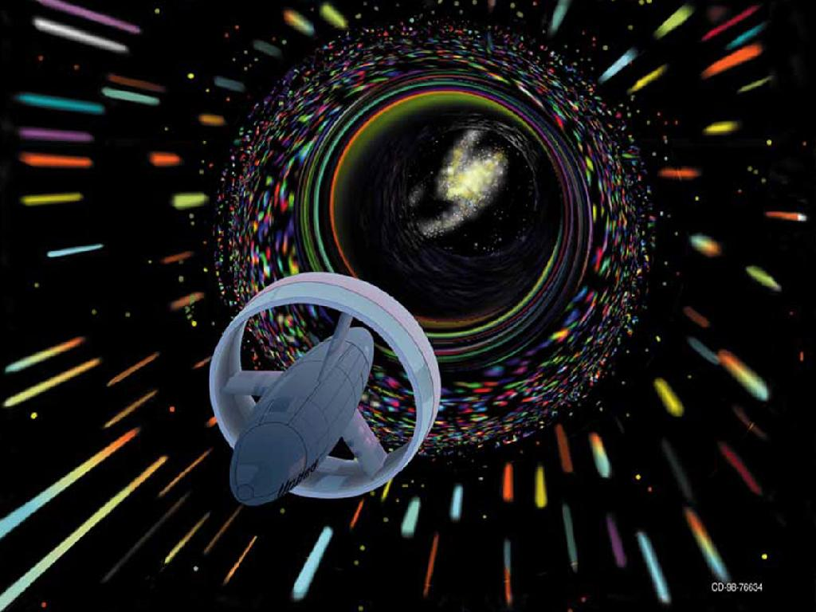
Down a wormhole or down a rabbit hole? Apparently a ring structure capable of generating negative energy (whatever the heck that is) could make instantaneous interstellar travel a breeze. Just step around a few fundamental principles of modern physics and sure... why not? Credit: NASA.

Science has its theorists and it has its experimenters and it has its data collectors - and many scientists operate across all those areas. And you might think that they would all be collaborating together like this:
- a data collector observes something and reports back - Hey I found this, what could it mean?
- a theorist says - Aha, I was thinking that might be the case and it's probably because a+b=c!
- an experimenter says, well if a+b=c, then b=c-a. I'll go and test that and if it's right, we can all write up a paper together.
In reality science doesn't always happen that way. Our capacity to observe the universe advances by the day, but it's a necessarily slow, careful and technology-dependent business. But our capacity to theorise and imagine has no such constraints. So it's more often the case that the theorists are 'out there', speculating on what it might be like to fall into a black hole centuries before we are likely to get around to dropping a probe into one.
There are some pretty 'out there' ideas that make their way into scientific publications, including a suggestion that we are already living in a black hole. It's more than likely that 90% of these ideas will be tossed out the window as the evidence of what is really going on steadily trickles in. But this still means that 10% of those 'out there' ideas might survive the evidence test. In the meantime, all this wild speculation does give a wannabe science journalist something to wield Occam's razor upon for a weekly blog post.

Is An Anomalous Anomaly A Normality?
April 3, 2010
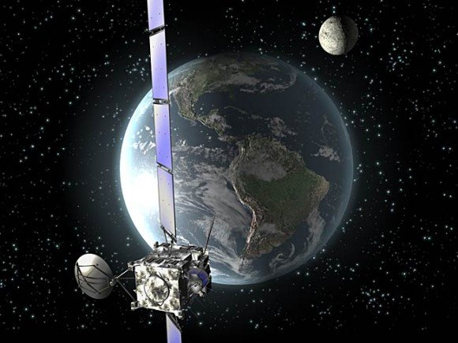
The Rosetta spacecraft showed an anomalous increase in speed during its first Earth flyby in 2005 - then on its second flyby in 2007 and third in 2009 it demonstrated what some considered an anomalous lack of anomaly in its expected speed. It is now on its way to comet 67P/Churyumov–Gerasimenko to do some useful science. Credit: ESA.
The lack of any flyby anomaly effect when the Rosetta spacecraft passed Earth in November 2009 is what? An anomaly? No. Anomalies arise when there is a mismatch between a predicted and an observed value. When it happens our first thought shouldn’t be OMG there’s something wrong with physics! We should probably start by checking whether we really got the prediction right.
The flyby anomaly story starts with the Galileo spacecraft's flyby of Earth in December 1990 – where it was measured to have gained speed (over the predicted value) of 2.5 millimeters per second at perigee. In its second pass in December 1992, the predicted value was the same as the observed value, although it has been suggested that atmospheric drag effects confound any analysis of that particular flyby.
The next, and biggest anomaly so far detected, was the NEAR spacecraft's flyby in 1998 (a whopping increase of 7.2 millimeters per second over the predicted speed). After that you have Rosetta with an anomaly in its first flyby in 2005. Then a quantitative formula, which aimed to model the various flyby variations to date, was developed by Anderson et al in 2007. The formula predicted that a small but detectable speed increase would be found in Rosetta’s second flyby of 13 November 2007. However (or should I say anomalously), no such increase was detected in this, or in Rosetta’s third flyby, in 2009.
So, on balance, our spacecraft (and often the same spacecraft on different occasions) are more likely to behave as predicted than to behave anomalously. This reduces the likelihood of the anomaly being anything of substance. One might sagely state that the intermittent absence of an anomaly is not in itself anomalous.
More recently, Mbelek in 2009 has proposed that the anomalous flyby data (including Anderson et al’s formula) can be explained by a more rigorous application of special relativity principles, concluding that ‘spacecraft flybys of heavenly bodies may be viewed as a new test of SR which has proven to be successful near the Earth’. If such recalculated predicted values match observed values in future flybys, that would seem to be that.
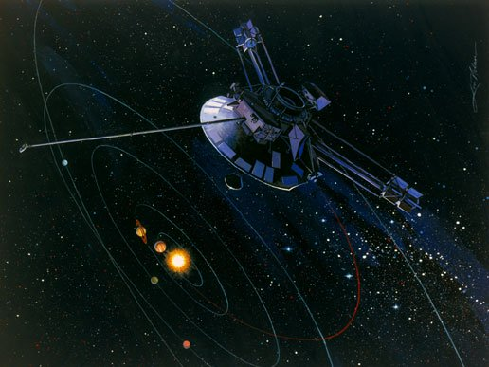
Pioneer 10 - launched in 1972 and now making its way out towards the star Aldebaran, which it should pass in about 2 million years. Credit: NASA
Then there’s the Pioneer anomaly. This has no obvious connection with the flyby anomaly, apart from a common use of the word anomaly, which gives us another epistemological maxim – two unrelated anomalies do not one bigger anomaly make.
Between around 20 and 70 astronomical units out from Earth, Pioneer 10 and 11 both showed tiny but unexpected decelerations of around 0.8 nanometers per second² – although again we are just talking about an observed value that differed from a predicted value.
Some key variables not considered in calculating the original predicted value were radiation pressure from sunlight-heated surfaces, as well as internal radiation generated from the spacecrafts’ own power source. A recent Planetary Society update of the ongoing review of the Pioneer data indicated that revised predicted values now show less discrepancy from the observed values. This doesn’t yet negate the anomaly – but given the trend for more scrutiny equaling less discrepancy, it does seem likely to be fully accounted for in the near future.
Don’t get me wrong, this is all very useful science, teaching us more about how our spacecraft operate out there in the field. I am just suggesting that when faced with a data anomaly perhaps our first reaction should be D'oh! rather than OMG!

Why The LHC Won’t Destroy The Earth
August 27, 2011
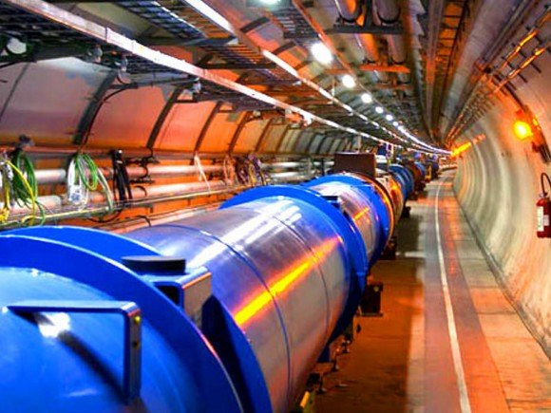
Concerns about a 'big science machine' destroying the Earth have been around since the steam engine. The Large Hadron Collider is the latest target for such conspiracy theories. Credit: CERN.
Surprisingly, rumors still persist in some corners of the Internet that the Large Hadron Collider (LHC) is going to destroy the Earth – even though nearly three years have passed since it was first turned on. This may be because it is yet to be ramped up to full power in 2014 – although it seems more likely that this is just a case of moving the goal posts, since the same doomsayers were initially adamant that the Earth would be destroyed at the moment the LHC was switched on in September 2008.
The story goes that the very high energy collisions engineered by the LHC could jam colliding particles together with such force that their mass would be compressed into a volume less than the Schwarzschild radius required for that mass. In other words, a microscopic black hole would form and then grow in size as it sucked in more matter, until it eventually consumed the Earth. Here’s a brief run-through of why this can’t happen.
1. Microscopic black holes are implausible.
While a teaspoon of neutron star material might weigh several million tons, if you extract a teaspoon of neutron star material from a neutron star it will immediately blow out into the volume you might expect several million tons of mass to usually occupy.
Although you can’t physically extract a teaspoon of black hole material from a black hole, the same principle should apply. You just can’t maintain these extreme matter densities outside of the region of extreme gravitational compression that is created by the proper mass of a stellar-scale object.
The hypothetical physics that might allow for the creation of microscopic black holes (large extra dimensions) proposes that gravity gains more force in near-Planck scale dimensions. There is no strong evidence available to support this theory – indeed there is a growing level of disconfirming evidence arising from various sources, including the LHC.
High energy particle collisions involve converting momentum energy into heat energy, as well as overcoming the electromagnetic repulsion that normally prevents same-charged particles from colliding. But the heat energy produced in these collisions quickly dissipates and the collided particles fragment into sub-atomic shrapnel, rather than fusing together. Particle colliders attempt to mimic conditions similar to the Big Bang, not the insides of massive stars.
2. A hypothetical microscopic black hole couldn’t devour the Earth anyway.
Although whatever goes on inside the event horizon of a black hole is a bit mysterious and unknowable, physics still operates in a conventional fashion outside. The gravitational influence exerted by the mass of a black hole declines in strength by the inverse square of the distance from it, just like it does for any other celestial body.
The gravitational influence exerted by a microscopic black hole composed of, let’s say 1000 hyper-compressed protons, would be laughably small from a distance of more than its Schwarzschild radius - which would be maybe 10⁻¹⁸ meters, which is a zero followed by a decimal point followed by another 17 zeros and then a 1 (of a meter).
Such a microscopic black hole would be unable to consume more matter unless it could overcome the forces that hold other matter together – remembering that in quantum physics, gravity is the weakest force (after the strong, weak and electromagnetic forces).
It’s been calculated that if the Earth had the density of solid iron, a hypothetical microscopic black hole in linear motion would be unlikely to encounter an atomic nucleus more than once every 200 kilometers – and if it did, it would encounter a nucleus that would be at least 1,000 times larger in diameter.
So the black hole couldn’t hope to swallow the whole nucleus in one go and, at best, it might chomp a bit off the nucleus in passing – somehow overcoming the strong nuclear force in so doing. The microscopic black hole might have 100 such encounters before its momentum carried it all the way through the Earth and out the other side, at which point it would probably still be a good order of magnitude smaller in size than an uncompressed proton.
And that still leaves the key issue of charge out of the picture. If you could jam multiple positively-charged protons together into such a tiny volume, the resulting object should explode, since the electromagnetic force far outweighs the gravitational force at this scale. You might get around this if an exactly equivalent number of electrons were also added in, but this requires appealing to an implausible level of fine-tuning.
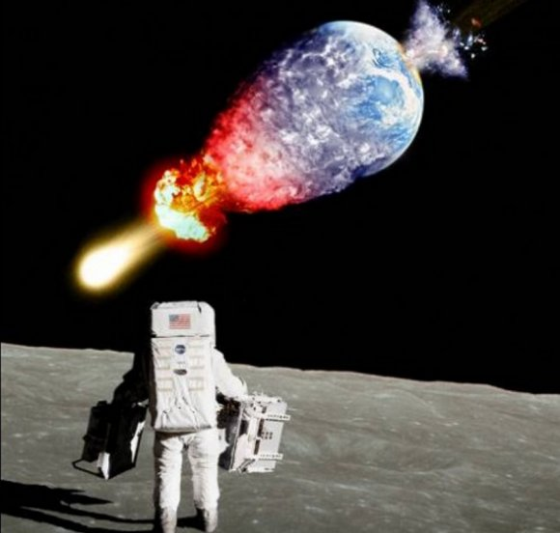
You maniacs! You blew it up! We may not be walking on the Moon again anytime soon, but we won't be destroying the Earth with an ill-conceived physics experiment anytime soon either. Credit: Dean Reeves.
3. What the doomsayers say
When challenged with the standard argument that higher-than-LHC energy collisions occur naturally and frequently as cosmic ray particles collide with Earth’s upper atmosphere, LHC conspiracy theorists refer to the high school physics lesson that two cars colliding head-on is a more energetic event than one car colliding with a brick wall. This is true, to the extent that the two car collision has twice the kinetic energy as the one car collision. However, cosmic ray collisions with the atmosphere have been measured as having 50 times the energy that will ever be generated by LHC collisions.
When challenged that a microscopic black hole would pass through the Earth before it could achieve any appreciable mass gain, LHC conspiracy theorists propose that an LHC collision would bring the combined particles to a dead stop and they would then fall passively towards the centre of the Earth with insufficient momentum to carry them out the other side.
This is also implausible. The minutest degree of transverse momentum imparted to LHC collision fragments after a head-on collision at nearly 300,000 kilometers a second will easily give those fragments an escape velocity from the Earth (which is only 11.2 kilometers a second, at sea-level).
Further reading: CERN The safety of the LHC.

Granularity
July 9, 2011
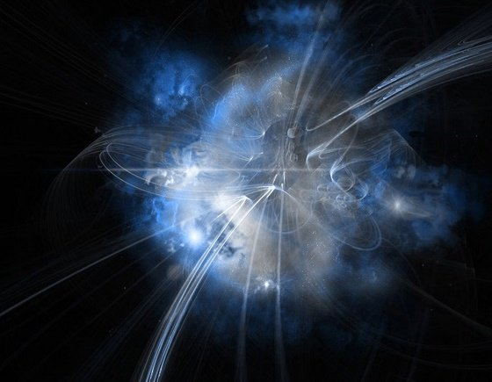
A gamma ray burst is an opportunity to assess the emptiness of the vacuum that exists between you and its source. In the case of GRB 041219A, that's 300 million light years of vacuum. Credit: ESA.
The very small wavelength of gamma ray light offers the potential to gain high resolution data about very fine detail – perhaps even detail about the quantum substructure of a vacuum – or in other words, the granularity of empty space.
Quantum physics suggests that a vacuum is anything but empty, with virtual particles regularly popping in and out of existence within Planck instants of time. The proposed particle nature of gravity also requires graviton particles to mediate gravitational interactions. So, to support a theory of quantum gravity we should expect to find evidence of a degree of granularity in the substructure of space-time.
There is a lot of current interest in finding evidence of Lorentz invariance violations – where Lorentz invariance is a fundamental principle of relativity theory – and (amongst other things) requires that the speed of light in a vacuum should always be constant.
Light is slowed when it passes through materials that have a refractive index – like glass or water. However, we don’t expect such properties to be exhibited by a vacuum – except, according to quantum theory, at exceedingly tiny Planck units of scale.
So theoretically, we might expect a light source that broadcasts across all wavelengths to have the very short wavelength portion of its spectrum affected by the vacuum substructure – while the rest of its spectrum isn’t so affected.
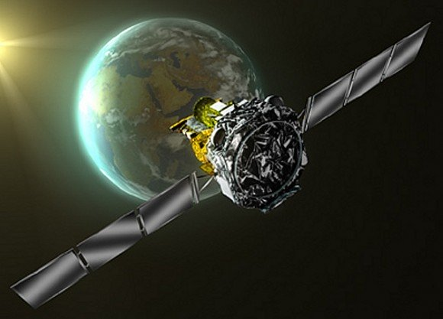
The ESA INTEGRAL gamma ray observatory - devoting a proportion of its observing time to searching for the underlying quantum nature of the cosmos. Credit: ESA
On 19 December 2004, the space-based INTEGRAL gamma ray observatory detected Gamma Ray Burst GRB 041219A, one of the brightest such bursts on record. The radiative output of the gamma ray burst showed indications of polarisation – and we can be confident that any quantum level effects should have been exaggerated by the fact that the burst occurred in a different galaxy and the light from it has travelled through more than 300 million light years of vacuum to reach us.
The extent of polarization attributed to the substructure of the vacuum would only be visible in the gamma ray portion of the light spectrum – and it was found that the difference between polarisation of the gamma ray wavelengths and the rest of the spectrum was… well, undetectable.
The authors of a recent paper on the INTEGRAL data claim that it achieved resolution down to Planck scales, being 10⁻³⁵ meters. Indeed, INTEGRAL’s observations constrain the possibility of any quantum granularity down to a level of 10⁻⁴⁸ meters or smaller.
This finding might be welcomed by relativity physicists since assigning a structural composition to the vacuum of space, makes it possible to act as a background reference frame – similar to the hypothetical luminiferous ether which Einstein dismissed the need for by establishing his relativity physics.
Elvis might not have left the building, but the authors of this study claim that their finding should have a major impact on any current quantum gravity theories that require a vacuum to have a Planck scale substructure. So, this should send quite a few theorists back to the drawing board.
Further reading: Laurent et al. Constraints on Lorentz Invariance Violation using INTEGRAL/IBIS observations of GRB041219A.

The Universe Is Not In A Black Hole
July 31, 2010
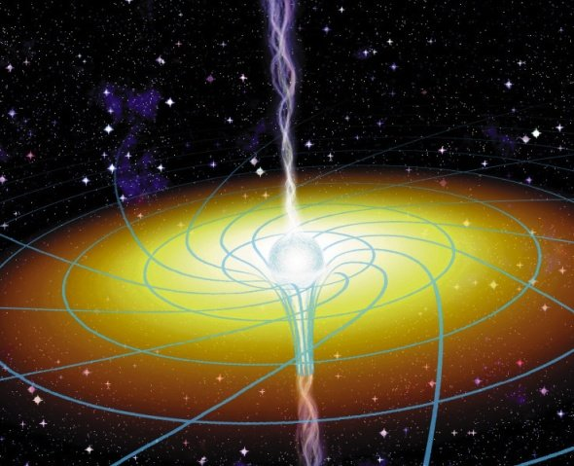
Can a spinning massive object wind up space-time? Credit: J Bergeron / Sky and Telescope Magazine. An Astronomy Picture of the Day (APOD) for 7 November 1997.
It has been erroneously reported that a recent scientific paper delivers the conclusion that our universe resides inside a black hole in another universe. In fact, this isn’t really what the paper concluded – although what the paper did conclude is still a little out of left field.
The Einstein-Cartan-Kibble-Sciama (ECKS) theory of gravity is claimed as an alternative to general relativity theory, although still based upon the Einstein Field Equations. It seeks to take greater account of the effect of the spin of massive particles. Essentially, while general relativity has it that matter determines how space-time curves, ECKS also tries to capture the torsion of space-time, which is a more dynamic idea of curvature. So, with ECKS you have to think in terms of twisting and contortion, rather than just curvature.
Mind you, general relativity is also able to deal with dynamic curvature. ECKS proponents claim that where ECKS departs from general relativity is in situations with very high matter density – such as inside black holes. General relativity suggests that a singularity (with infinite density and zero volume) forms beyond a black hole’s event horizon. This is not a very satisfying result since the contents of black holes do seem to occupy volume – more massive ones have larger diameters than less massive ones – so general relativity may just not be up to the task of dealing with black hole physics.
ECKS theory attempts to step around the singularity problem by proposing that an extreme torsion of space-time, resulting from the spin of massive particles compressed within a black hole, prevents a singularity from forming. Instead the intense compression increases the intrinsic angular momentum of the matter within (i.e. the spinning skater draws arms in analogy) until a point is reached where space-time becomes as twisted, or as wound up, as it can get. From that point the tension must be released through an expansion (i.e. an unwinding) of space-time in a whole new tangential direction – and voila you get a new baby universe.
But the new baby universe can’t be born and expand in the black hole. Remember this is all about general relativity. From any frame of reference outside the black hole, the events just described cannot sequentially happen. Clocks seem to slow to a standstill as they approach a black hole’s event horizon. It makes no sense for an external observer to imagine that a sequence of events is taking place inside a black hole as they watch.
Instead, it is proposed that the birth and expansion of a new baby universe proceeds along a separate branch of space-time with the black hole acting as an Einstein-Rosen bridge (i.e. a wormhole).
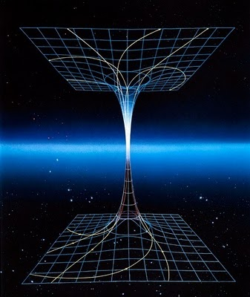
Since it is impossible to get any information out of black hole, it is an ideal place to park an unlikely astrophysics theory – since no-one can easily prove you wrong. Credit: Wikimedia.
If correct, it’s just a 'turtles all the way down' solution and we are left to ponder the mystery of the first primeval universe which first formed the black holes from which all subsequent universes originate.
What’s interesting about ECKS is that the torsion concept provides an alternative explanation to cosmic inflation. Matter and energy crunched within a black hole should achieve a state of isotropy and homogeneity. So, when it unwinds and expands through its wormhole escape route, it explodes out as a smooth, unblemished expanse of space-time. So you have an explanation for why a universe expands – and why it begins its life such an isotropic and homogeneous state.
Further reading: Poplawski, N.J. (2010) Cosmology with torsion – an alternative to cosmic inflation.

Enough With The Dark Already
June 4, 2011
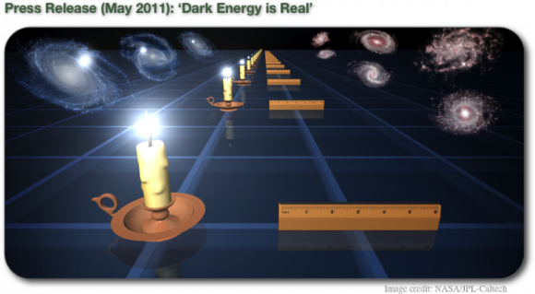
It has been further confirmed that the universe is expanding with a uniform acceleration. But dark energy is still just as dark as ever. Credit: Swinburne/NASA/JPL-Caltech.
The recent WiggleZ galaxy survey data, further confirming that the universe is expanding with a uniform acceleration, prompted a lot of ‘astronomers confirm dark energy’ headlines and a lot of heavy sighs from those preferring not to have the universe described in ten words or less.
I mean how the heck did ‘dark energy’ ever become shorthand for ‘the universe is expanding with a uniform acceleration’?
These ‘dark energy confirmed’ headlines risk developing a popular view that the universe is some kind of balloon that you pump energy into to make it expand. This is not an appropriate interpretation of the dark energy concept – which only came into common use after 1998 with the announcement of Type 1a supernova data demonstrating an accelerating expansion of the universe.
It was widely accepted well before then that the universe was expanding. A prevalent view before 1998 was that expansion might be driven by the outward momentum of the universe’s contents – a momentum possibly established from the initial cosmic inflation event that followed the Big Bang.
But no one really thinks that now. Current thinking on the expansion of the universe does not associate its expansion to the momentum of its contents. Instead the universe is thought of as raisin toast dough which expands in an oven – not because the raisins are pushing the dough outwards, but because the dough itself is expanding. As a consequence the distance between the raisins (analogous to galaxies) increases.
It’s not a perfect analogy since space-time is not a substance – and the heat of the oven represents the input of energy from outside the universe – and being thermal energy, it’s not dark energy.
Alternatively, you can model the universe as a perfect fluid where you think of dark energy as a negative pressure - which expands the fluid since a positive pressure would compress the fluid. A negative pressure does not obviously require additional contents to be pumped into the fluid universe, although the physical nature of what a negative pressure is remains to be explained.
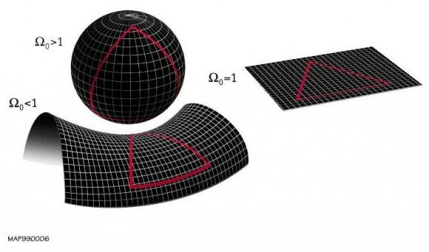
Various possible shapes of the observable universe - where mass/energy density is too high, too low or just right (omega = 1), so that the geometry is Euclidean and the three angles of a triangle do add up to 180 degrees. Our universe does appear to have a flat Euclidean geometry, but it doesn't have enough visible mass/energy required to make it flat. Hence, we assume there must be a lot of dark stuff out there. Credit: Wikimedia/MAP990006
The role of dark energy in standard model cosmology is to sustain the observable flat geometry of space – which is presumed to be maintained by the mass-energy contents of the universe. Too much mass-energy should give a spherical shape to space, while too little mass-energy should give a hyperboloid shape. Dark energy makes everything just right.
If this is true, then dark energy must be a component of the universe that grows as the universe grows in volume, in order to sustain the flat geometry.
We call this dark stuff ‘energy’ as it is evenly distributed (i.e. not prone to clumping, the way that dark matter is), but otherwise it has no analogous properties with any form of energy that we know about.
So, the primary requirement for dark energy is not as a driver of expansion. Of course, this then raises the question of just what is driving the accelerating expansion of the universe. And the appropriate answer to that question is – we haven’t a clue.
A plausible mechanism that accounts for the input of energy out of nowhere – and a plausible form of energy that is both invisible and that somehow generates the production of more space-time volume – are both required to support the view that dark energy underlies the universe’s accelerating expansion.
I'm not saying that we might not eventually discover something that fulfils all these requirements, but no way has anyone confirmed that dark energy is real yet. Our universe has a surprisingly flat Euclidean geometry and it is expanding with a uniform acceleration – and no-one knows why. For now, this is the news story.
Further reading:
Expansion of the universe
Shape of the universe

Warp Drive On Paper
October 30, 2010
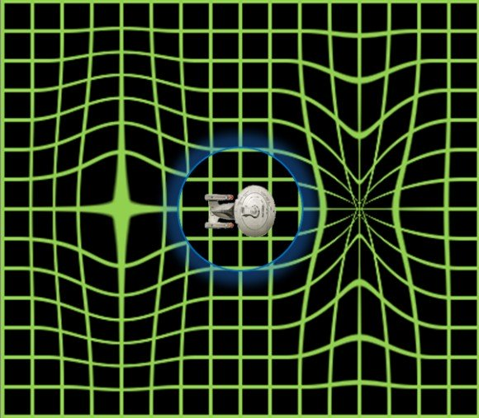
It's sixteen years since Miguel Alcubierre suggested that faster-than-light travel might be achieved by generating a warp bubble that contracts space-time ahead of the spaceship and expands it behind. Now a metamaterial test laboratory is available to see if this idea really could work. Credit: Anon, sourced from andersoninstitute.com
The Alcubierre drive is one of the better known warp drive on paper models – where a possible method of warp drive seems to work mathematically as long as you don’t get too hung up on real world physics.
Recently the Alcubierre drive concept has been tested within mathematically modeled metamaterial – which can provide a rough analogy for space-time. Interestingly, in turns out that under these conditions the Alcubierre drive is not able to break the light barrier – but it is quite capable of doing 25% of light speed, which is not what you would call slow.
OK, so two conceptual issues to grapple with here. What the heck is an Alcubierre drive and what the heck is metamaterial?
The Alcubierre drive is a kind of mathematical thought experiment where you imagine your spacecraft has a drive mechanism capable of warping a bubble of space-time such that the component of bubble in front of you contracts (bringing points ahead of you closer) – while the bubble behind you expands (moving what’s behind you further away).
This warped geometry moves the spacecraft forward, like a surfer on a wave of space-time. Maintaining this warp dynamically and continuously as the ship moves forward could result in faster-than-light velocities from the point of view of an observer outside the bubble – while the ship hardly moves at all relative to the local space-time within the bubble. Indeed throughout the journey the crew experience free fall conditions and are not troubled by G forces.
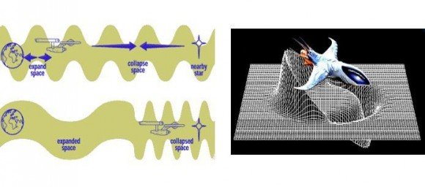
Standard images used to describe the Alcubierre drive. Left: Want to make the Kessel run in 12 parsecs? No problem - just compress the Kessel run into 12 parsecs. Right: The Alcubierre concept can be thought of as a spaceship surfing on a self-propagating wave of space-time. Credit: Anon, sourced from daviddarling.info.
However, there are some problems with the Alcubierre drive model. Although the mathematics suggests that forward movement of the ship within a warp bubble is theoretically possible, how it might start and then later stop at its destination are not clear. The mechanism underlying generation of the bubble also remains to be explained. To warp space-time, you must redistribute mass or energy density in some way.
Furthermore, there's a problem at the edges of the bubble. Since particles at the boundary of the bubble would be moving faster than light when viewed from a frame of reference external to the bubble, a fundamental principle relativity physics would be violated.
There are various work-around solutions proposed, involving negative energy, exotic matter and tachyons – although you must be well down the rabbit-hole already to feel comfortable invoking such notions. However, if you can believe six impossible things before breakfast, an Alcubierre drive won't be too hard to swallow.
Now, metamaterials are matrix-like structures with geometric properties that can control and shape electromagnetic waves (as well as acoustic or seismic waves). To date, such materials have not only been theorized, but built – at least to manipulate long wavelength radiation. But theoretically, very finely precisioned metamaterials might be able to manipulate optical and shorter wavelengths – creating the potential for invisibility cloaks and spacecraft cloaking devices… well, theoretically.
Anyhow, metamaterials capable of manipulating most of the electromagnetic spectrum can be mathematically modeled – even if they can’t be built at the moment. Such modeling has been used to create virtual black holes and to investigate the likelihood of Hawking radiation. So, why not use the same approach to test an Alcubierre warp drive?
It turns out that the material parameters of even so-called ‘perfect’ metamaterial will not allow the Alcubierre drive to break light speed, but will allow it to achieve 25% light speed – being around 75,000 kilometers a second. This gets you to the Alpha Centauri system in about seventeen years, assuming the acceleration and deceleration steps only represent small components of the journey.
Whether the limitations imposed by metamaterials in this test are an indication that they cannot adequately emulate warped space-time – or whether the Alcubierre drive just can’t break light speed remain open questions. What is surprising and encouraging is that the drive could actually work… at least a bit.
Further reading: Smolyaninov, I. Metamaterial-based model of the Alcubierre warp drive.

7. Aliens

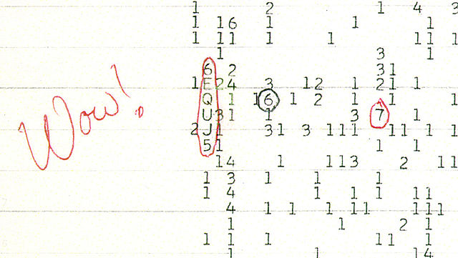
The Wow signal detected in 1977 by the Big Ear radio telescope in Ohio showed many features that had been predicted for an artificial and extrasolar broadcast. It lasted for 72 seconds, coming from the vicinity of the star Tau Sagittarii. All subsequent attempts to detect an equivalent signal from that region have failed. Credit: Wikimedia.

So here we are - thinking and therefore being. And there are such a stupendous number of stars and galaxies out there, that it seems almost daft to suppose that it is just us.
But perhaps it's equally daft to think we can just point a receiving dish into the sky and tune into some cosmic tweet-up. If nothing else, all our SETI efforts to date have ruled out any chance of us sharing the galaxy with two armed, two legged humanoids with different lumpy bits on their foreheads. We can be quite confident that, if and when we meet them, interbreeding will not be the first thing on our minds. The aliens will be... alien.
But we will still be children of the same universe - our lives governed by the same principles of mathematics, physics and chemistry. It would be unusual to find we did not both use electromagnetic radiation as a means of communicating over long distances and that we did not share water and carbon as our biochemical roots. But, it's likely that those things will be about all that we do have in common and it will be down to the scientists and the geeks on both sides to take the conversation forward. Of course, that may turn out to be a very good thing.
The following stories consider what we should be looking for and some thinking around what they might be like.

Planet Spotting
May 8, 2011
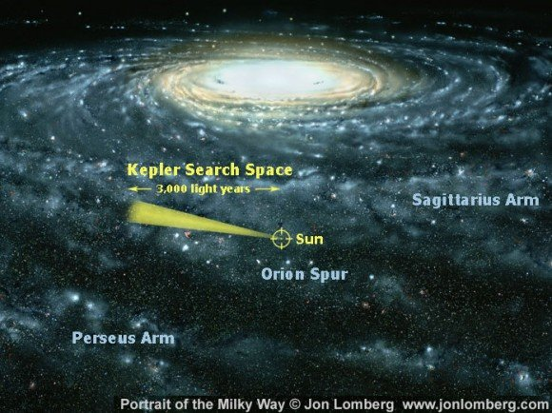
The current search area of the Kepler mission, monitoring 145,000 stars for signs of extrasolar planets - with a particular interest in those that may be in their star's 'habitable zone'. Credit: Lomberg/NASA.
The Extrasolar Planets Encyclopedia had counted 548 confirmed extrasolar planets at 6 May 2011, while the NASA Star and Exoplanet Database (updated weekly) was today reporting 535. These counts will significantly increase as more candidate exoplanets are assessed and then confirmed. For example, there were 1,235 candidates announced by the Kepler mission in February, including 54 that may be in a habitable zone.
So, what techniques are brought to bear to come up with these findings?
Pulsar timing – A pulsar is a neutron star with a polar jet roughly aligned with Earth. As the star spins and a jet comes into the line of sight of Earth, we detect an extremely regular pulse of light – like a lighthouse beacon. Indeed, it is so regular that a slight wobble in the star’s motion, due to it possessing planets, is detectable.
The first extrasolar planets (i.e. exoplanets) were found in this way, actually three of them, around the pulsar PSR B1257+12 in 1992. Of course, this technique is only useful for finding planets around pulsars, none of which could be considered habitable – at least by current definitions – and, in all, only 4 such pulsar planets have been confirmed to date.
To look for planets around main sequence stars, we have…
The radial velocity method – This is similar in principle to detection via pulsar timing anomalies, where a planet or planets shift their star back and forth as they orbit, causing tiny changes in the star’s velocity relative to the Earth. These changes are generally measured as shifts in a star’s spectral lines, detectable via Doppler spectrometry, although detection through astrometry (direct detection of minute shifts in a star’s position in the sky) is also possible.
To date, the radial velocity method has been the most productive method for exoplanet detection (finding 500 of the 548 confirmed exoplanets), although it most frequently picks up massive planets in close stellar orbits (i.e. hot Jupiters) – and as a consequence these planets are over-represented in the current confirmed exoplanet population. Also, in isolation, the method is only effective up to about 160 light years from Earth – and only gives you the minimum mass, not the size, of the exoplanet.
To determine a planet’s size, you can use…
The transit method – The transit method is effective at both detecting exoplanets and determining their diameter – although it has a high rate of false positives. A star with a transiting planet, which partially blocks its light is, by definition, a variable star. However, there are many different reasons why a star may be variable – many of which do not involve a transiting planet.
For this reason, the radial velocity method is often used to confirm a transit method finding. Thus, although 128 planets are attributed to the transit method – these are also part of the 500 counted for the radial velocity method. The radial velocity method gives you the planet’s mass – and the transit method gives you its size (diameter) – and with both these measures you can get the planet’s density. The planet’s orbital period (by either method) also gives you the distance of the exoplanet from its star, by Kepler’s (that is, Johannes) Third Law. And this is how we can determine whether a planet is in a star’s habitable zone.
It is also possible, from consideration of tiny variations in transit periodicity (i.e. regularity) and the duration of transit, to identify additional smaller planets (in fact 8 have been found via this method, or 12 if you include pulsar timing detections). With increased sensitivity in the future, it may also be possible to identify exomoons in this way.
The transit method can also allow a spectroscopic analysis of a planet’s atmosphere. So, a key goal here is to find an Earth analogue in a habitable zone, then examine its atmosphere and monitor its electromagnetic broadcasts – in other words, scan for life signs.
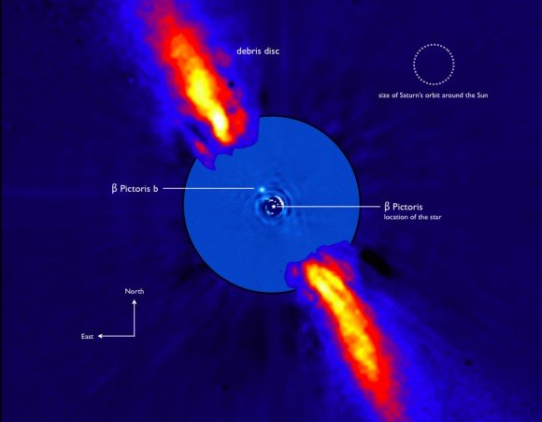
Direct imaging of exoplanet Beta Pictoris b - assisted by nulling interferometry which removes Beta Pictoris' starlight from the image. The red flares are a circumstellar debris disk heated by the star. Credit: European Southern Observatory.
To find planets in wider orbits, you could try…
Direct imaging – This is challenging since a planet is a faint light source near a very bright light source (the star). Nonetheless, 24 have been found this way so far. Nulling interferometry, where the starlight from two observations is effectively cancelled out through destructive interference, is an effective way to detect any fainter light sources normally hidden by the star’s light.
Gravitational lensing – A star can create a narrow gravitational lens and hence magnify a distant light source – and if a planet around that star is in just the right position to slightly skew this lensing effect, it can make its presence known. Such an event is relatively rare – and then has to be confirmed through repeated observations. Nonetheless, this method has detected 12 so far, which include smaller planets in wide orbits such as OGLE-2005-BLG-390Lb.
These current techniques are not expected to deliver a complete census of all planets within current observational boundaries, but do offer us an impression of how many there may be out there. It has been speculatively estimated, from the scant data available so far, that there may be 50 billion planets within our galaxy. However, a number of definitional issues remain to be fully thought through, such as the point at which a massive planet should be considered to be a brown dwarf star. The Extrasolar Planets Encyclopedia currently sets the limit for planets at 20 Jupiter masses.
Anyhow, 548 confirmed exoplanets for only 19 years of planet spotting is not bad going. And the search continues.
Further reading:
The Extrasolar Planets Encyclopedia
The NASA Star and Exoplanet Database (NStED)
Methods of detecting extrasolar planets
The Kepler mission

SETI 2.0
June 19, 2010
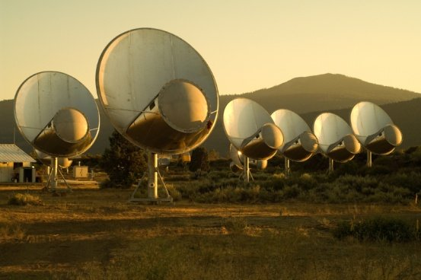
Component dishes of the Allen Telescope Array - which, amongst other things, is intended to continue the Search for Extraterrestrial Intelligence (SETI) Credit: SETI Institute.
Fifty years of eerie silence in the search for extra-terrestrial intelligence has prompted some rethinking about what we should be looking for.
After all, it’s unlikely that many civilizations would invest a lot of time and resources into broadcasting a Yoo-hoo, over here signal, so maybe we have to look for incidental signs of alien activity – anything from atmospheric pollution on an exoplanet to signs of stellar engineering undertaken by an alien civilization working to keep their aging star from turning into a red giant.
We know a spectroscopic analysis of Earth’s atmosphere will indicate free molecular oxygen – a tell tale sign of life. The presence of chlorofluorocarbons would also be highly suggestive of advanced industrial activity. We also know that atomic bomb tests in the fifties produced perturbations to the Van Allen belts that probably persisted for weeks after each blast.
These are planet level signs of a civilization still below the level of a Kardashev Type 1 civilization. We are at level 0.73 apparently. A civilization that has reached the Type 1 level is capable of harnessing all the power available upon a single planet – and might inadvertently signal its presence after thoughtfully disposing of large quantities of nuclear waste in its star. To find them, we should be scanning A and F type stars for spectral signatures of technetium – or perhaps an overabundance of praseodymium and neodymium.
We might also look for signs of stellar engineering indicative of a civilization approaching the Kardashev Type 2 level, which is a civilization able to harness all the power of a star. Here, we might find an alien civilization in the process of star lifting, where an artificial equatorial ring of electric current creates a magnetic field sufficient to both increase and deflect all the star’s stellar wind into two narrow polar jets.
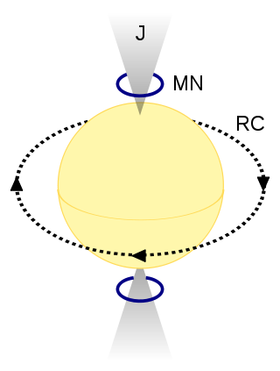
A proposed model for 'star lifting'. An artificial equatorial ring of electric current (RC) produces a magnetic field which enhances and directs the star's stellar wind though magnetic nozzles (MN) to produce two polar jets (J). Credit: Wikimedia.
These jets could be used for power generation, but might also represent a way to prolong the life of an aging star. Indeed, this may become a vital strategy for us to prolong the solar system’s habitable zone at Earth’s orbit. In less than a billion years, Earth’s oceans are expected to evaporate due to the Sun’s steadily increasing luminosity, but some carefully managed star lifting to modify the Sun’s mass could extend this time limit significantly.
It’s also likely that Type 2 civilizations will tinker with Hertzsprung–Russell (H-R) parameters to keep their Sun from evolving onto the red giant branch of the H-R diagram – or otherwise from going supernova. Some well placed and appropriately shielded nuclear bombs might be sufficient to stir up stellar material that would delay a star’s shift to core helium fusion – or otherwise to core collapse.
It’s been hypothesized that the mysterious giant blue straggler stars, which have not gone supernova like most stars of their type would have, may have been tinkered with in this manner (although stress on the word hypothesized there).
As for detecting Type 3 civilizations… tricky. It’s speculated that they might build Dyson nets around supermassive black holes to harvest energy at a galactic level. But indications are that they might then just use all that energy to go around annoying the starship captains of Type I civilizations. So, maybe we need to start drawing a line about who exactly we want to find out there.
Further reading:
Carrigan, R. Starry Messages: Searching for Signatures of Interstellar Archaeology.
Lemarchand, G. Detectability of Extraterrestrial Technological Activities.

Alien Mining
April 24, 2011
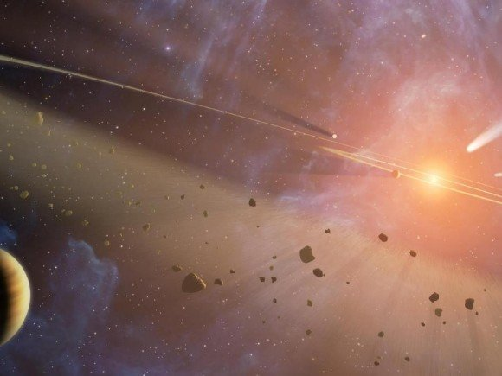
A disk of debris around a star is a likely indicator of planets. A disk of debris with atypical chemistry and density might be an indicator of an alien asteroid mining operation. Might be. Credit: NASA.
Recently, some researchers speculated on what types of observational data from distant planetary systems might indicate the presence of an alien civilization. They determined that asteroid mining was something likely to be worth looking for, but then concluded that most of the effects of such activity would be difficult to distinguish from natural phenomena anyway.
In any case, aren’t we anthropomorphizing aliens by assuming their intelligent activity will be anything like human activity?
Currently, electromagnetic transmissions (like radio) carrying artificial content remains the favored target for SETI. But beyond that, it’s thought that indicators of the presence of an alien civilization might include:
• Atmospheric pollutants, like chlorofluorocarbons – which, unlike methane or molecular oxygen, are clearly manufactured rather than just biochemically produced
• Propulsion drive signatures – like how the Vulcans detected humanity in Star Trek: First Contact (or at least it made them decide we were worth visiting after all, despite all the I Love Lucy re-runs)
• Stellar engineering – where a star’s lifetime is artificially extended to maintain a habitable zone for its planets
• Dyson spheres – or at least their more plausible variants, such as Dyson nets or swarms.
And perhaps add to this list – asteroid mining, which would potentially create dust and debris around a star on a scale that might be detectable from Earth.
There is a lot of current interest in debris disks around other stars, which become detectable when they are heated up by the star they surround and then radiate that heat in the infra-red and sub-millimeter wavelengths. For mainstream science, debris disk observations may offer another way to detect exoplanets, which might produce clumping patterns in the dust through gravitational resonance. Indeed it may turn out that the presence of a debris disk strongly correlates with the existence of rocky terrestrial planets in that system.
But going off the mainstream… presuming that we can eventually build up a representative database of debris disk characteristics, including their density, granularity and chemistry derived from photometric and spectroscopic analysis, it might become possible to identify anomalous debris disks that could indicate alien mining activities.
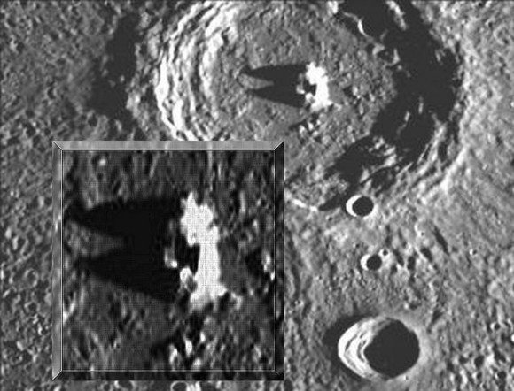
Some astronomy pareidolia. It turns out this mysterious structure within one of Mercury's many craters is not an alien mining operation, but a chunk of solidified ejecta commonly found in the center of many impact craters. Credit: NASA.
For example, we might see a significant deficiency in a characteristic element (say, iron or platinum) because the aliens had extracted these elements. Or we might see an unusually fine granularity in the disk because the aliens had ground everything down to fine particles before extracting what they wanted.
But if the aliens are technologically advanced enough to undertake asteroid mining, might they not also undertake it with efficient techniques that would not leave any debris behind?
The gravity of Earth makes it easy enough to just blow up big chunks of rock to get at what you want since all the debris just falls back to the ground and you can sort through it later for secondary extraction.
Following this approach with an asteroid would produce a floating debris field that might represent a risk to spacecraft, as well as leaving you without any secondary extraction opportunities. Better to mine under a protective canopy or just send in some self-replicating nanobots, which can separate out an enriched chunk of the desired material and leave the remainder intact.
If we are hunting for advanced alien civilizations perhaps we need to start with the assumption that they are, you know... advanced.
Further reading:
Some useful tips on asteroid mining can be found here.

Necropanspermia
November 13, 2010
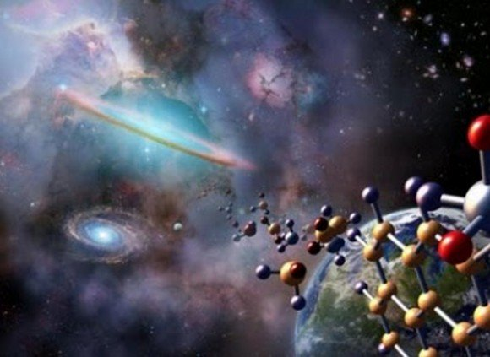
Could an alien spore really travel light years between different star systems? Well, as long as it doesn't have to be alive when it arrives - sure it can. Credit: NASA.
The idea that a tiny organism could hitchhike aboard a mote of space dust and cross vast stretches of space and time until it landed and took up residence on the early Earth does seem a bit implausible. More than likely any such organisms would have been long dead by the time they reached Earth. But… might those long dead alien carcasses still have provided the genomic template that kick-started life on Earth? Welcome to necropanspermia.
Panspermia, the theory that life originated somewhere else in the universe and was then transported to Earth, requires some consideration of where that somewhere else might be. As far as the solar system is concerned, the most likely candidate site for the spontaneous formation of a water-solvent carbon-based replicator is… well, Earth. And, since all the solar system's planets are of a similar age, the only obvious reason to need somewhere else for life to have spontaneously arisen is if a much longer time span is needed than was available on the early Earth.
Opinions vary, but Earth may have offered a reasonably stable and watery environment from about 4.3 billion years until 3.8 billion years ago, which is when the first evidence of life becomes apparent in the fossil record. This represents a good half billion years for some kind of primitive chemical replicator to evolve into a self-contained microorganism capable of metabolic energy production – and capable of reproducing another self-contained microorganism to keep the line going.
Half a billion years sounds like a generous amount of time – although with the Earth as the only example to go by, who knows what a generous amount of time really is. Wesson argues that it is not enough time – referring to other researchers who calculate that random molecular interactions over half a billion years would only produce about 194 bits of information – while a typical virus genome carries 120,000 bits and an E. coli bacterial genome carries about 6 million bits.
A counter argument to this is that any level of replication in an environment with limited raw materials will always favor those entities that are most efficient at replication – and this principle continues to work generation after generation. This means an environment like the early Earth would very quickly cease to be an environment of random molecular interactions and instead it would become a hot bed of natural selection.
Put the term panspermia in a search engine and you get (left) ALH84001, a meteorite from Mars which has some funny looking structures which may just be mineral deposits; and (right) a tardigrade, a terrestrial organism that can endure high levels of radiation, desiccation and near vacuum conditions - although it much prefers wet moss. Credit: NASA.
The mechanism through which a dead alien genome might usefully become the information template for further organic replication on Earth is not described in detail and the necropanspermia theory is not immediately compelling.
To kick-start the world as we know it, the theory requires that the early Earth was ideally primed and ripe for seeding – with a gently warmed cocktail of organic compounds, shaken-but-not-stirred, beneath a protective atmosphere and magnetosphere.
Under these circumstances, the establishment of a primeval replicator through a fortuitous conjunction of organic compounds already on Earth seems just as plausible as the fortuitous arrival of a dead interstellar genome. And if life didn't start abiogenically on Earth, we are again left with the problem of how our interstellar ancestry ever got started.
Further reading: Wesson, P. Panspermia, past and present: Astrophysical and Biophysical Conditions for the Dissemination of Life in Space.

Why Water?
January 8, 2011
Mono Lake. No alien biochemistry here (it's in California). Credit: NASA.
The assumption that alien biochemistries probably require liquid water may seem a little Earth-centric. But given the chemical possibilities available, from the most abundant elements in the universe, even an alien scientist with a different biochemistry would probably agree that a water-solvent-based biochemistry is more than likely to occur elsewhere in the universe – and would be the most likely foundation for intelligent life to develop.
Based on what we know of life and biochemistry, it seems likely that an alien biochemistry will need a solvent (like water) and one or more elemental units for its structure and function (like carbon). Solvents are important to enable chemical reactions, as well as physically transporting materials – and in both contexts, having that solvent in its liquid phase seems vital.
We might expect that biochemically-useful solvents are most likely to form from the most common elements in the universe – being hydrogen, helium, oxygen, neon, nitrogen, carbon, silicon, magnesium, iron and sulfur, in that order.
You can probably forget about helium and neon – both noble gases, they are largely chemically inert and only rarely form chemical compounds, none of which obviously have the properties of a solvent. Looking at what’s left, the polar solvents that might be most readily available to support biochemistry are firstly water (H₂O), then ammonia (NH₃) and hydrogen sulfide (H₂S). Various non-polar solvents can also be formed, notably methane (CH₄). Broadly speaking, polar solvents have a weak electric charge and can dissolve most things that are water-soluble, while non-polar solvents have no charge and act more like the industrial solvents we are familiar with on Earth, such as turpentine.
Isaac Asimov, who was a biochemist as well as a science fiction writer, proposed a hypothetical biochemistry where poly-lipids (essentially chains of fat molecules) could substitute for proteins in a methane (or other non-polar) solvent. Such a biochemistry might work on Saturn’s moon, Titan.
Nonetheless, from the list of potentially abundant solvents in the universe, water looks to be the best candidate to support a complex ecosystem. After all, it is likely to be the most universally abundant solvent anyway – and its liquid phase occurs at a warmer temperature range than any of the others.
It seems reasonable to assume that a biochemistry will be more dynamic in a warmer environment with more energy available to drive biochemical reactions. Such a dynamic environment should mean that organisms can grow and reproduce (and hence evolve) that much faster.
Water also has the advantages of:
- having strong hydrogen bonds that give it a strong surface tension (three times that of liquid ammonia) – which would encourage the aggregation of prebiotic compounds and the development of membranes;
- being able to form weak non-covalent bonds with other compounds – which, for example, supports the 3D structure of proteins in Earth biochemistry; and
- being able to engage in electron transport reactions (the key method of energy production in Earth biochemistry), by donating a hydrogen ion and its corresponding electron.
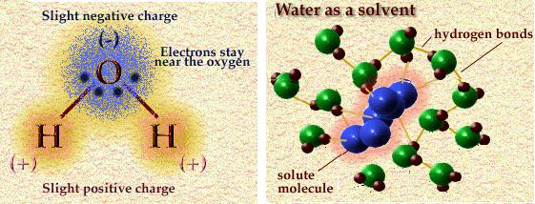
Water's polar nature - and also its solvent nature. Credit: Addison-Wesley.
Hydrogen fluoride (HF) has been suggested as an alternative stable solvent that could also engage in electron transport reactions – with a liquid phase between -80 ºC and 20 ºC at 1 atmosphere pressure (Earth, sea-level). This is a warmer temperature range than the other solvents that are likely to be universally abundant, apart from water. However fluorine itself is not a very abundant element and HF, in the presence of water, will turn into hydrofluoric acid.
Hydrogen sulfide (H₂S) can also be used for electron transport reactions – and is so used by some Earth-based chemosynthetic bacteria. But, as a fluid, it only exists in the relatively narrow and cold temperature range of -90 ºC to -60 ºC at 1 atmosphere.
These points at least make a strong case for liquid water being the most statistically likely basis for the development of complex ecosystems capable of supporting intelligent life. Although other biochemistries based on other solvents are possible, they may be limited to cold, low energy environments where the rate of development of biological diversity and evolution would be very slow.
The only exception to this rule might be high pressure environments which can sustain those other solvents in fluid phase at higher temperatures (where they would otherwise exist as a gas at a pressure of 1 atmosphere).
Further Reading:
Meadows et al The Search for Habitable Environments and Life in the Universe.
Wikipedia Hypothetical Types of Biochemistry.

Why Carbon?
January 15, 2011
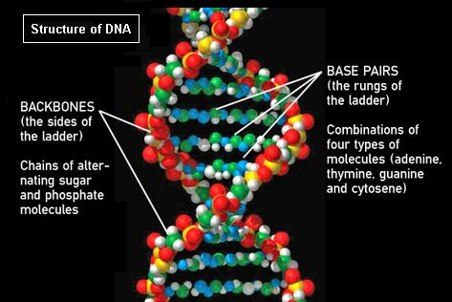
The ATGC coding of DNA. Currently, we are not really sure whether replication was the first biochemical step on Earth – or whether energy producing metabolizers came first, only adopting a replication system later on. Credit: NASA.
The previous article Why Water? took the approach of acknowledging that while numerous solvents are available to support alien biochemistries, water is very likely to be the most common biological solvent out there – just on the basis of its sheer abundance. It also has useful chemical features that would be advantageous to alien biochemistries, particularly where its liquid phase occurs in a warmer temperature zone than any other solvent.
We can constrain the number of possible solutes likely to engage in biochemical activity by assuming that life (particularly complex and potentially intelligent life) will need structural components that are chemically stable in solution and can sustain their structural integrity in the face of minor environmental variations, such as changes in temperature, pressure and acidity.
Although DNA is often discussed as a core component of life on Earth, it is conceivable that its self-replicating biochemistry came later. The molecular machinery that supports the breakdown of carbohydrates uses relatively uncomplicated carboxylic acids and phospholipid membranes – although the whole process today is facilitated by complex proteins, which are unlikely to have arisen spontaneously. A current debate exists about whether life originated as a replication or metabolic system – or whether the two systems arose separately before joining together in a symbiotic alliance.
In any case, although a variety of small scale biochemistries, with or without carbon, may be possible – it seems likely that the structure of organisms of any substantial size will need to be built using polymers. These large molecular structures, built up from the joining together of smaller units.
On Earth, we have proteins built from amino acids, DNA built from nucleotides and deoxyribose sugars. We also have various polysaccharides (for example cellulose or glycogen) built from simple sugars. With only microscopic mechanisms capable of building these small units and then linking them together – Earth biochemistry makes blue whales.
Possibly too much science, but this represents the other possible first step in Earth biology. We imagine there might have been some self-contained precursor of the Krebs cycle, where carbohydrate goes in, carbon dioxide and water come out and the binding energy released is available for useful work. Credit Wikimedia.
Carbon is extremely versatile at linking together diverse elements, able to form more compounds than any other element we have so far observed. Also, it is more universally abundant that the next polymeric contender, silicon. As it happens, Earth is unusual in having 900 times more silicon than carbon – but even then silicon ends up having a minimal role in Earth biochemistry. Boron is another elemental polymer-building candidate, but boron is a relatively rare element in the universe.
On this basis, it does seem reasonable to assume that if we ever meet a macroscopic alien life form – with a structural integrity sufficient to enable us to shake hands – it is very likely to have a primarily carbon-based structure.
However, in this scenario you are likely to be met with a puzzled query as to why you seek tactile engagement between your respective motile-sensory appendages. It may be more appropriate to offer to replenish your new alien friend’s solvents with some heated water mixed with a nitrogen, oxygen and carbon alkaloid – something we call coffee.
Further Reading:
Meadows et al The Search for Habitable Environments and Life in the Universe.
Wikipedia Hypothetical Types of Biochemistry.

About the author

Steve Nerlich is one of the Universe Today writing team and writer/publisher of the Cheap Astronomy website and its weekly podcasts. He is also one of the crack team of volunteer explainers at the Canberra Deep Space Communication Complex, part of NASA's Deep Space Network. When not otherwise distracted, he is pursuing a PhD in science education at the Australian National University.

